GHAR MITRA
SYSTEM
Project Report

Submitted in partial fulfilment of the requirements for the award of the degree of M.C.A.
Project Title: Rental Room Management System
Submitted by:
- Name: Anjali Prasad
- Roll Number: 2610
- Name: Bhakti Angadi
- Roll Number: 2613
Under the guidance of: Sir Hanumant Redkar and Sir Sarvesh Velip
Department: M.C.A.
Institution: Goa University
Academic Year: 2026 -2027

CERTIFICATE
This is to certify that the project entitled “Rental Room Management System” has been developed by Anjali Prasad and Bhakti Angadi of M.C.A. Department, Goa University, under the guidance of Sir Hanumant Redkar and Sir Sarvesh Velip.
The project has been undertaken as part of the academic requirements for Object Oriented Technology Lab Mini Project Assignment. The work presented in this report describes the analysis, design, development, and testing of a mobile-based rental room management application.
Project Guide: Sir Hanumant Redkar and Sir Sarvesh Velip
Head of Department: Preeti Khorjuvenkar
Date: 26 October 2026
Place: G.B.S, Goa University

DECLARATION
We declare that the project titled “Rental Room Management System” has been prepared as part of our academic work. The report describes the proposed and implemented functionality of the application to the best of our knowledge.
All external resources, libraries, documentation, and references used during development will be acknowledged appropriately. Any screenshots, results, or implementation details included in the final submission should correspond to the actual application.
Student Name: Anjali Prasad
Roll Number: 2610
Student Name: Bhakti Angadi
Roll Number: 2613
Date: 26 October 2026

ACKNOWLEDGEMENT
We would like to express our sincere gratitude to our project guide, Sir Hanumant Redkar and Sir Sarvesh Velip, for the guidance and support provided during the development of the Rental Room Management System.
We are thankful to the Head of the Department, faculty members, and our institution for providing the academic environment and resources required to complete this project.
We also acknowledge the developers and maintainers of the technologies and tools used in the project, including Android development tools, Java, Firebase, and the supporting libraries used during implementation.

ABSTRACT
The Rental Room Management System is an Android application designed to simplify the process of finding, listing, and managing rental rooms. Traditional room-rental processes often involve manual searching, repeated communication between tenants and property owners, difficulty maintaining room information, and limited mechanisms for collecting feedback or handling complaints.
The proposed system provides two primary user roles: Tenant and Owner. Both users can register and log in to the application. Owners can add rental rooms, edit room information, update their profiles, receive reviews, and view complaints related to their rooms. Tenants can search for rooms, apply filters, send room requests, update their profiles, submit reviews, register complaints, and configure monthly payment notification.
The application aims to centralize rental-related activities in a convenient mobile interface. Firebase-based services are used for relevant application functions, subject to the actual project configuration. The system is intended to improve accessibility, reduce repetitive manual work, and support communication between tenants and owners.
The project follows a software development process involving requirement analysis, system design, implementation, testing, and evaluation. The final report documents the application's objectives, requirements, architecture, database design, modules, testing approach, limitations, and possible future enhancements.
Keywords: Rental Management, Android Application, Java, Firebase, Tenant, Owner, Room Search, Reviews, Complaints, Payment Reminder.

TABLE OF CONTENTS
- Introduction
- Project Background and Problem Statement
- Brainstorming and Idea Selection
- Objectives and Scope
- Existing System and Proposed System
- Feasibility Study
- Software and Hardware Requirements
- Requirement Analysis
- System Architecture
- System Design and Diagrams
- Database Design
- Tenant Module
- Owner Module
- Room Requests, Reviews, and Complaints
- Monthly Payment Reminder
- Implementation Details
- Testing and Validation
- Results and Discussion
- Challenges and Limitations
- Future Enhancements
- Conclusion
- References

CHAPTER 1: INTRODUCTION
1.1 Introduction
Accommodation is an important requirement for students, working professionals, families, and individuals who move to a new location for education or employment. Finding a suitable rental room can be difficult when information is scattered across different sources or when the process depends on personal contacts and manual communication.
Property owners also face challenges in maintaining room details, communicating with potential tenants, keeping their profiles updated, and receiving structured feedback from tenants.
The Rental Room Management System is an Android-based application developed to make these activities more organized. It provides separate functionality for tenants and owners, allowing each user type to access features relevant to their needs.
Tenants can browse available room information, search and filter rooms, submit room requests, maintain their profiles, give reviews, register complaints, and configure monthly payment reminders. Owners can register, log in, manage their profiles, add rooms, update room details, and access feedback or complaints concerning their properties.
The application brings these operations together in a single mobile platform.

1.2 Project Background
Rental arrangements frequently involve several activities: discovering a property, comparing room details, contacting an owner, requesting accommodation, and managing ongoing rental responsibilities.
When these activities are performed manually, information may become outdated, communication may be delayed, and tenants may find it difficult to keep track of recurring payment dates.
A mobile application can make rental information easier to access and provide a structured way to manage room listings and user interactions. The Rental Room Management System applies this approach through an Android application.
1.3 Problem Statement
The project addresses the following problems:
- Difficulty discovering rental rooms in a convenient and organized way.
- Limited ability to filter room listings according to user preferences.
- Manual maintenance of rental room details by owners.
- Repeated communication required for room requests.
- Lack of a centralized place for reviews and room-related complaints.
- Difficulty remembering monthly rental payment dates.
- Need for separate, role-appropriate features for tenants and owners.
The system is intended to reduce these difficulties through a mobile interface and centralized application data.

1.4 Motivation
The main motivation behind the project is to make rental-room discovery and management more convenient. The application focuses on practical requirements from both sides of a rental arrangement rather than supporting only room searching.
The tenant features cover discovery, requests, feedback, complaints, and payment reminders. The owner features cover room listing management, profile maintenance, and feedback received from tenants.

1.5 Purpose of the Project
The purpose of the project is to develop an Android application that organizes important rental-related activities and improves access to room information.
The application is intended to:
- Provide registration and login for tenants and owners.
- Allow owners to add and edit room listings.
- Allow tenants to search and filter rooms.
- Support submission of room requests.
- Support profile management for both user roles.
- Provide review and complaint functionality.
- Help tenants remember monthly payment dates through monthly notification.
1.6 Organization of the Report
This report begins with the project background and requirements. It then explains the design, architecture, database structure, tenant and owner modules, implementation approach, testing strategy, and possible future enhancements.

CHAPTER 2: PROJECT BACKGROUND AND PROBLEM STATEMENT
2.1 Overview of Rental Management
Rental management includes the activities involved in advertising rooms, finding tenants, communicating room requirements, receiving feedback, and managing recurring rental responsibilities.
A digital rental system can make these activities more structured by storing room information and user details in an organized form.

2.2 Problems Faced by Tenants
Tenants may have difficulty finding rooms that match their budget, location, or other preferences. They may also need a convenient way to request accommodation and communicate their experiences.
Monthly rental payments create another recurring responsibility. A reminder feature can help tenants remember their configured due dates.

2.3 Problems Faced by Owners
Owners need to maintain accurate room descriptions and update information when room details change. They may also need to review feedback and complaints from tenants.
A centralized application helps owners manage their listings and access relevant feedback without relying entirely on separate manual records.

2.4 Proposed Solution
The proposed solution is a role-based Android application with a tenant interface and an owner interface. It organizes room listings, user profiles, room requests, reviews, complaints, and monthly payment reminders within a single application.

2.5 Expected Benefits
- Easier access to room information.
- More organized room listing management.
- Convenient searching and filtering.
- Structured submission of room requests.
- Centralized reviews and complaints.
- Better awareness of monthly payment dates.
- Improved usability through mobile access.

CHAPTER 3: BRAINSTORMING AND IDEA SELECTION
3.1 Initial Brainstorming
During the planning stage, the project concept can be examined from the perspectives of tenants and owners.
Potential ideas include:
- A room-search application.
- An owner-focused room listing manager.
- A rental platform with tenant and owner accounts.
- A rental application with additional automated assistance.

3.2 Evaluation of Ideas
The project concept can be evaluated using criteria such as usefulness, implementation effort, technical feasibility, and relevance to rental management.
Idea | Benefit | Consideration
Room search | Helps tenants discover rooms | Requires accurate room data
Owner room management | Simplifies listing maintenance | Requires owner authentication
Room requests | Organizes tenant interest | Request status management may be needed
Reviews and complaints | Supports feedback | Requires appropriate access control
Monthly reminders | Helps users remember due dates | Requires notification and scheduling support

3.3 Selected Project Idea
The selected concept is the Rental Room Management System, which combines room discovery for tenants with listing management for owners.
The selection is appropriate because it addresses several connected activities in one application instead of focusing on only one part of the rental process.

3.4 Rejected or Deferred Ideas
Deferred Features: Ideas such as integrated online rent payments, identity verification, digital rental agreements, map-based recommendations, and advanced recommendation algorithms can be considered future enhancements.

Rejected Idea: Application only for room owners to list their room along with room details and their location.

CHAPTER 4: OBJECTIVES AND SCOPE
4.1 Main Objective
The main objective is to develop a mobile-based rental room management application that supports tenants and owners through dedicated functionality.

4.2 Specific Objectives
- Develop registration and login functionality for both user roles.
- Provide owner profile management.
- Enable owners to add and edit room details.
- Provide tenant profile management.
- Enable room searching and filtering.
- Support room request submission.
- Allow tenants to submit reviews and complaints.
- Allow owners to access feedback associated with their rooms.
- Provide monthly rental payment notifications.
- Organize the application around a clear and usable interface.

4.3 Project Scope
The project covers the following functional areas:
Authentication: Registration and login for tenants and owners.
Room management: Creating and updating rental room listings.
Room discovery: Searching and filtering room information.
Room requests: Allowing tenants to express interest in a room.
Profile management: Updating the information associated with user accounts.
Feedback management: Submitting reviews and complaints and making relevant feedback available to owners.
Payment reminders: Configuring monthly reminders for rental payments.

4.4 Users of the System
Tenant: The tenant uses the application to find rooms, submit requests, maintain personal details, provide feedback, and configure payment reminders.

Owner: The owner uses the application to manage rental room listings, maintain profile details, and review feedback or complaints associated with their rooms.

4.5 Project Boundaries
The application should not be assumed to process actual rent payments, execute legally binding rental agreements, verify property ownership, or provide guaranteed dispute resolution unless these capabilities are implemented separately.

CHAPTER 5: EXISTING SYSTEM AND PROPOSED SYSTEM
5.1 Existing System
Rooms Hai:- A Nagpur based rental system

5.2 Proposed System
The proposed system provides a mobile application with separate tenant and owner functions.
Tenants can search and filter rooms, send room requests, update profiles, provide reviews, submit complaints, and configure monthly payment reminders.
Owners can register, log in, add and edit room details, update profiles, and view reviews and complaints related to their rooms.

5.3 Comparison
Feature | Manual approach | Proposed application
Room discovery | Often spread across sources | Centralized room listings
Room filtering | Manual comparison | Search and filter functions
Listing updates | Separate communication or records | Owner editing interface
Room requests | May rely on direct contact | Request submission feature
Profile management | Separate records | In-app profile management
Reviews and complaints | May be informal | Structured feedback features
Payment reminders | Personal manual tracking | Configurable monthly reminders

5.4 Advantages of the Proposed System
The application brings several related tasks into one interface, provides role-specific functionality, and creates a foundation for future improvements to rental management.

CHAPTER 6: FEASIBILITY STUDY
6.1 Technical Feasibility
The project uses Android application development technologies and a backend data service. Java is used for the Android application, while Firebase can provide authentication and database services depending on the configured implementation.

6.2 Economic Feasibility
Development can be carried out using commonly available development tools. Android Studio and Java development tools can be used without purchasing a commercial development environment. Firebase and other hosted services may have usage limits or charges depending on the selected plan and actual usage.

6.3 Operational Feasibility
The system is intended for users who are comfortable using a smartphone. Separate interfaces for tenants and owners help users access functions relevant to their roles.

6.4 Schedule Feasibility
The work was divided into requirement gathering, design, implementation, integration, testing, and documentation. This division supports incremental development and makes it easier to identify incomplete features.

6.5 Conclusion of Feasibility Study
The project is technically and operationally plausible using standard Android and backend technologies. Its final feasibility depends on successful integration, testing, service availability, and the resources available to the project team.

CHAPTER 7: SOFTWARE AND HARDWARE REQUIREMENTS
7.1 Software Requirements
Component | Purpose
Android Studio | Android application development
Java | Application programming language
Android SDK | Android platform APIs and build tools
Firebase Authentication | User authentication
Firebase database service | Storage of application data
Gradle | Project build and dependency management
Android emulator and physical device | Running and testing the application
Git | Version control
Additional services, including a backend for AI-assisted chat, should be documented only if they are part of the version being submitted.

7.2 Hardware Requirements
Development system:
- Computer capable of running Android Studio.
- Sufficient RAM and storage for the IDE, SDK, and emulator.
- Internet connection for downloading dependencies and accessing cloud services.

End-user device:
- Compatible Android smartphone or emulator.
- Sufficient storage and memory to run the application.
- Internet connectivity for features requiring remote authentication or database access.

7.3 Development Environment
The exact Android SDK version, Gradle version, minimum Android version, Firebase dependencies, and device specifications should be copied from the actual project configuration rather than estimated.

CHAPTER 8: REQUIREMENT ANALYSIS
8.1 Functional Requirements
Tenant Requirements
TFR-01: Registration
The system shall allow a tenant to create an account.
TFR-02: Login
The system shall allow a registered tenant to log in.
TFR-03: Room Search
The tenant shall be able to search available room listings.
TFR-04: Room Filtering
The tenant shall be able to filter room listings using the criteria supported by the application.
TFR-05: Room Request
The tenant shall be able to submit a request for a selected room.
TFR-06: Profile Editing
The tenant shall be able to update supported profile details.
TFR-07: Reviews
The tenant shall be able to submit a review for a relevant room or owner, according to the application's implementation.
TFR-08: Complaints
The tenant shall be able to submit a complaint concerning a room or rental experience.
TFR-09: Monthly Payment Reminder
The tenant shall be able to configure a monthly reminder for rental payment.
Owner Requirements
OFR-01: Registration
The system shall allow an owner to create an account.
OFR-02: Login
The system shall allow a registered owner to log in.
OFR-03: Add Room
The owner shall be able to create a room listing.
OFR-04: Edit Room
The owner shall be able to update the details of an existing room listing.
OFR-05: Profile Editing
The owner shall be able to update supported profile details.
OFR-06: View Reviews
The owner shall be able to view reviews associated with their room listings.
OFR-07: View Complaints
The owner shall be able to view complaints associated with their room listings.
8.2 Non-Functional Requirements
Usability: The interface should be understandable to tenants and owners.
Performance: Common operations such as opening room lists and displaying profiles should complete within a reasonable time under normal network conditions.
Security: User-specific operations should be protected through authentication and suitable authorization rules.
Reliability: The application should handle failed network requests and invalid input without crashing.
Maintainability: Code should be organized into understandable components to support updates.
Compatibility: The application should support the Android versions declared by the project.
Data integrity: Room requests, reviews, complaints, and profile details should be associated with the correct users and rooms.
8.3 User Input Validation
The application should validate required fields, acceptable formats, and relevant constraints before submitting information. Error messages should explain what the user needs to correct.

8.4 Security Requirements
The system should ensure that owners can edit only their own listings and that tenants cannot change another user's profile or submit unauthorized modifications. Database security rules should enforce these permissions instead of relying exclusively on the visible interface.

CHAPTER 9: SYSTEM ARCHITECTURE
9.1 Architectural Overview
The application follows a mobile-client architecture in which users interact with the Android interface and application operations communicate with the configured backend services.
The logical architecture contains three main layers:
- Presentation layer: Activities, layouts, forms, room lists, profile screens, and other user interface components.
- Application logic layer: Validation, navigation, role-specific operations, and processing of user actions.
- Data and service layer: Authentication, room data, profile information, requests, reviews, complaints, and reminder-related data.
The exact boundaries depend on how the source code implements each feature.

9.2 Tenant Workflow
- The tenant opens the application.
- The tenant registers or logs in.
- The tenant opens the room-search interface.
- The tenant searches or filters available listings.
- The tenant selects a room and reviews its information.
- The tenant submits a room request if interested.
- The tenant may update their profile, submit feedback, or configure a payment reminder.

9.3 Owner Workflow
- The owner registers or logs in.
- The owner opens the owner interface.
- The owner adds a room or selects an existing listing.
- The owner enters or updates room information.
- The owner saves the changes.
- The owner accesses reviews and complaints associated with their listings.

9.4 Data Flow
User input is collected through the Android interface, validated by the application, and passed to the relevant backend service. The response is then displayed to the user. Network errors, permission failures, and invalid input should be handled appropriately.

CHAPTER 10: SYSTEM DESIGN AND DIAGRAMS

List of Diagrams
1. Use Case Diagram
2. Class Diagram – Model Layer
3. Class Diagram – Service Layer
4. Class Diagram – Application Layer
5. Sequence Diagram – Registration and Login
6. Sequence Diagram – Rental Request and Owner Approval
7. Sequence Diagram – Rent Payment and Verification
8. Sequence Diagram – Monthly Rent Reminder
9. Sequence Diagram – Complaint and Review
10. Activity Diagram – Rental Lifecycle
11. State Diagram – Rental Request
12. State Diagram – Payment
13. State Diagram – Complaint and Room Availability
14. ER Diagram – Firestore Collections
15. Component Diagram
16. Deployment Diagram
17. Screen Navigation Diagram

1. Use Case Diagram
Actors (Tenant, Owner, background reminder system) and the features each can perform, derived from the tenant and owner home screens and the actions each screen performs.
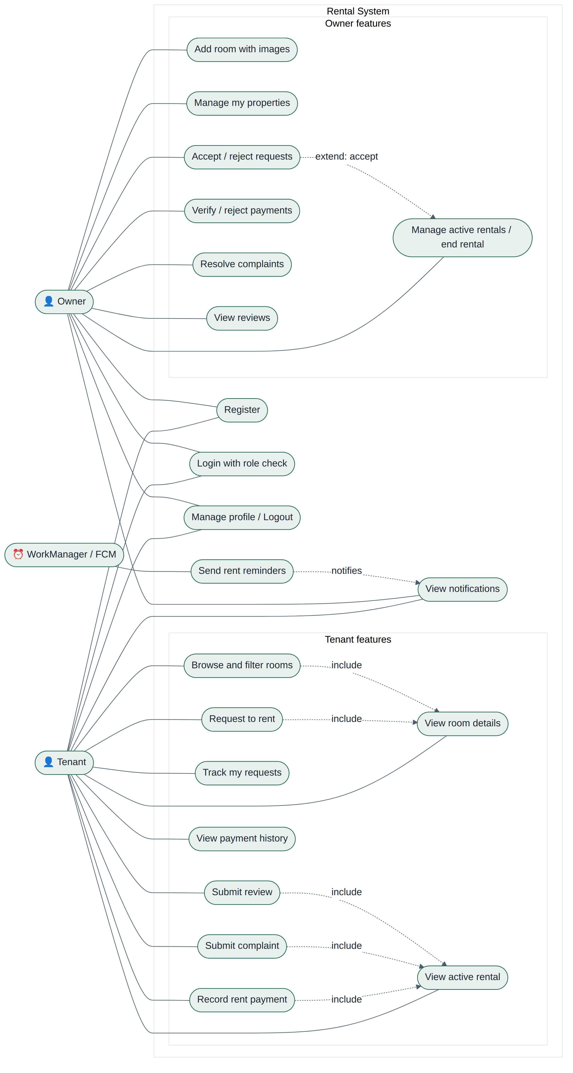
Figure: Use Case Diagram

2. Class Diagram – Model Layer
Domain classes in the model package. Entities reference one another by stored String IDs (Firestore style), shown here as associations. Tenant and Owner extend User.
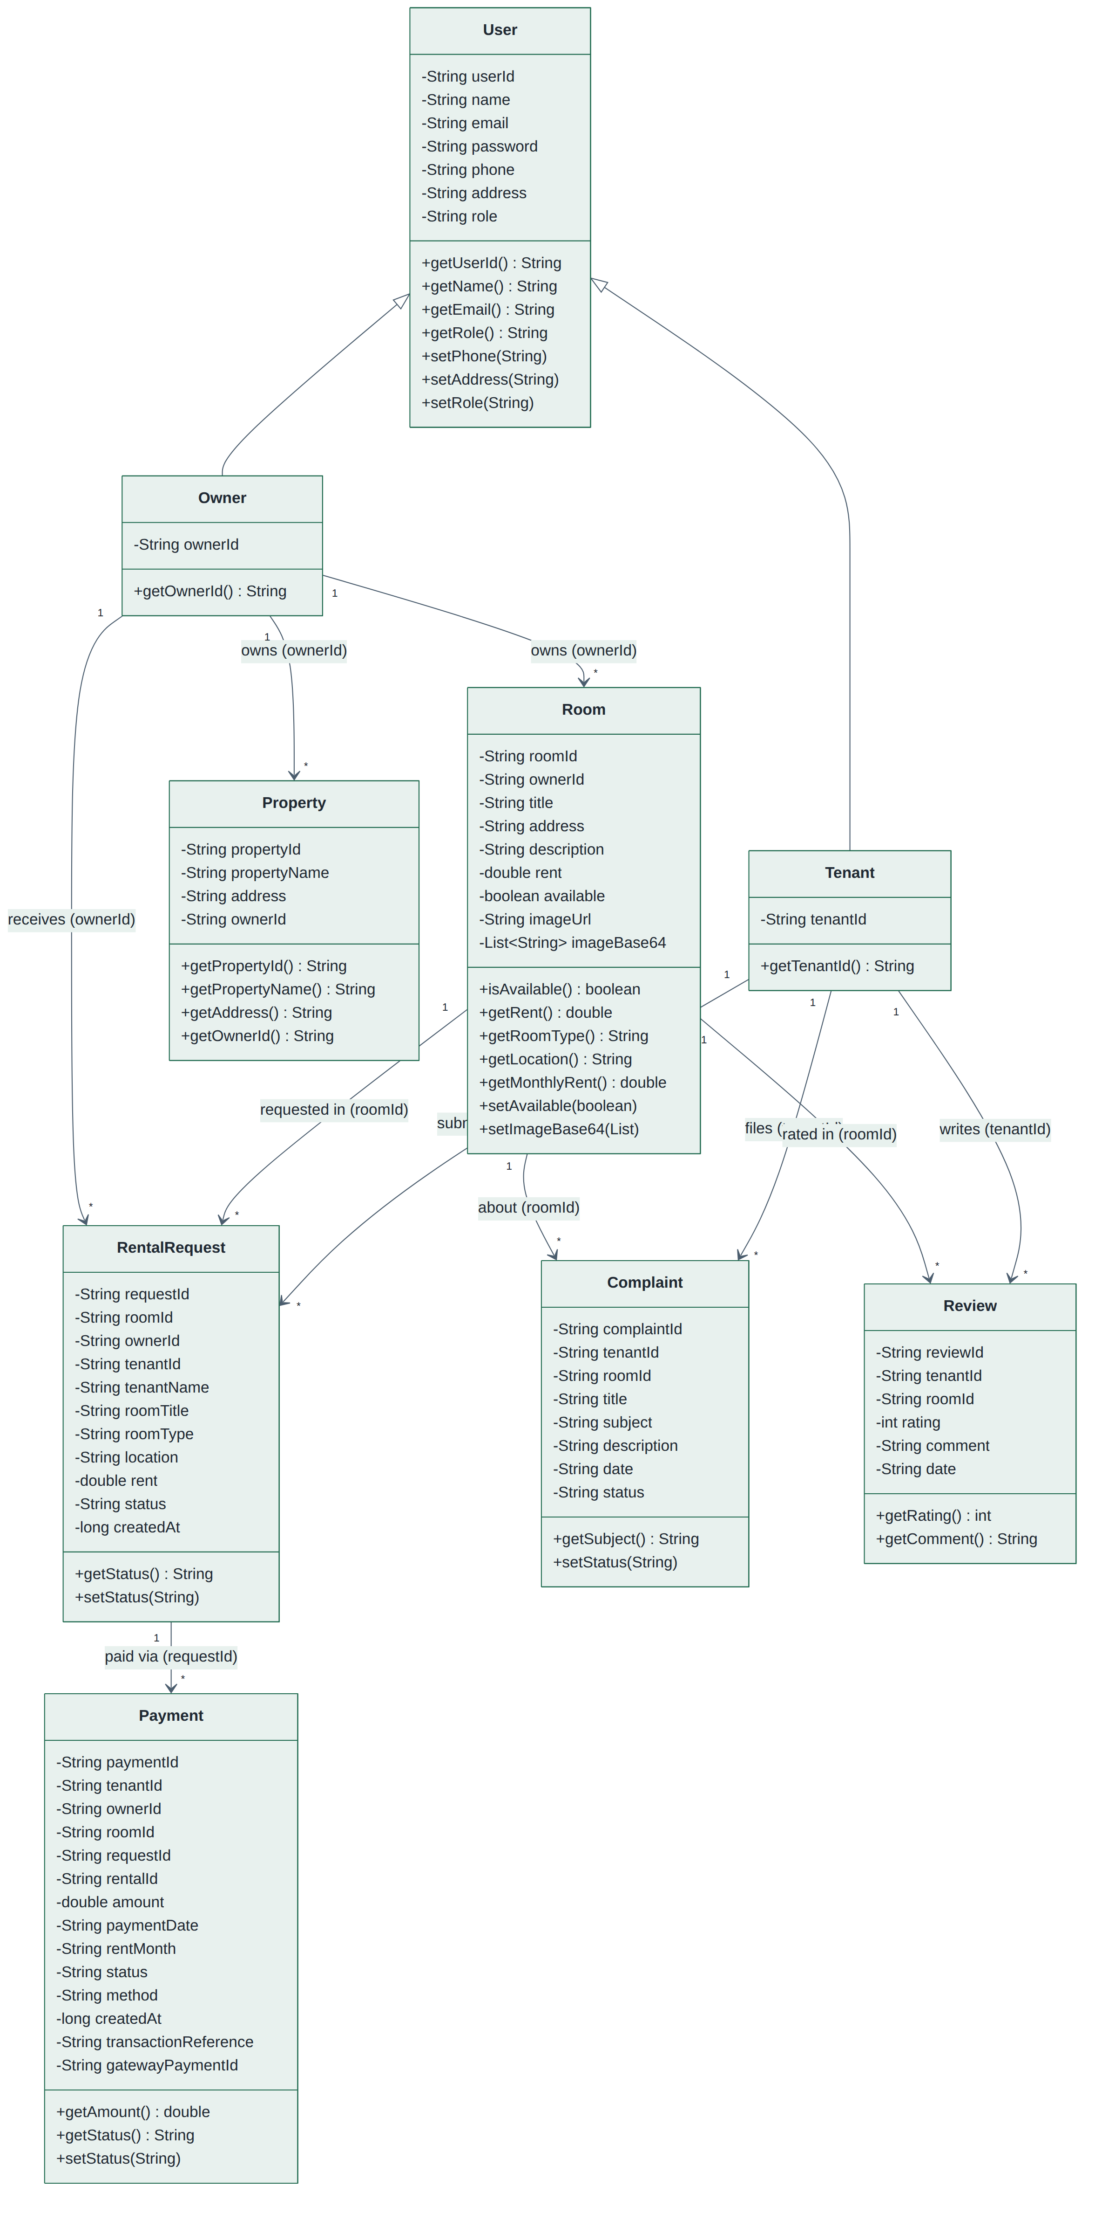
Figure: Class Diagram – Model Layer

3. Class Diagram – Service Layer
Abstract RentalService and its concrete subclass TenantRentalService (demonstrates abstraction and polymorphism).
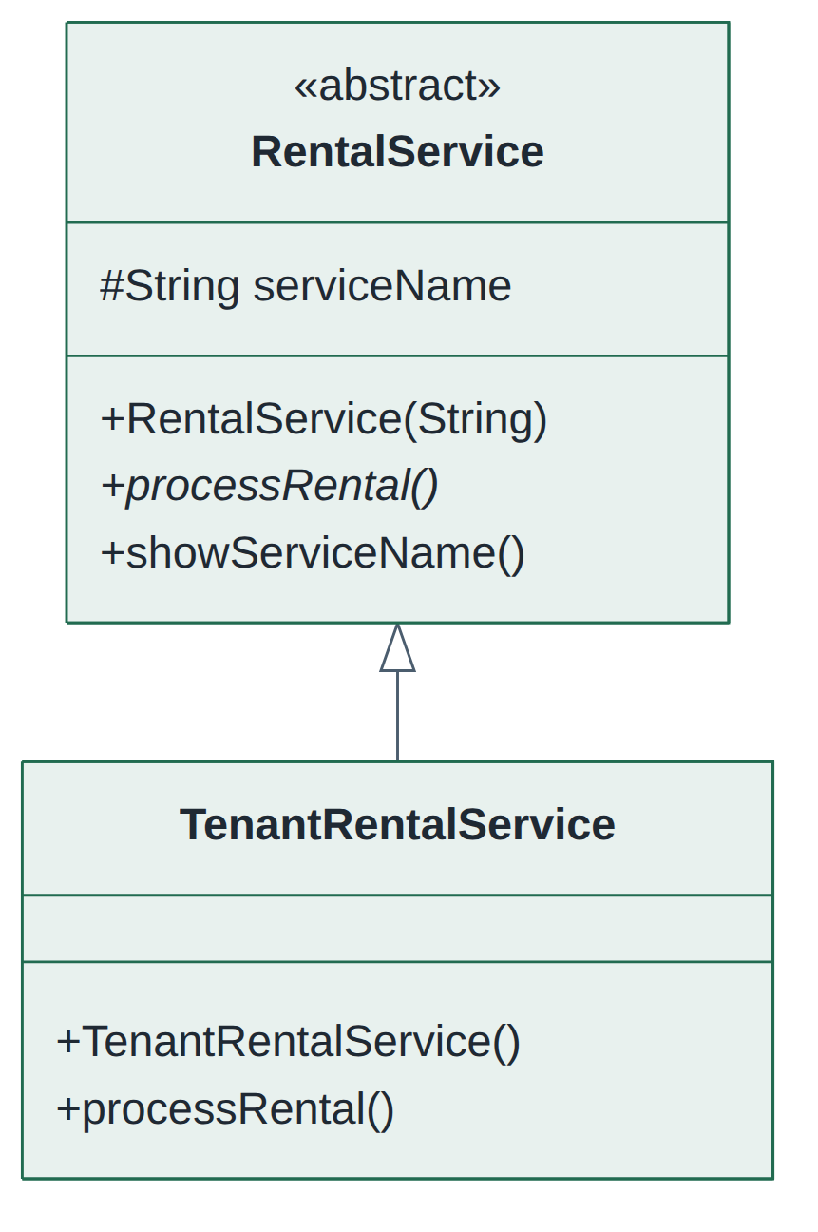
Figure: Class Diagram – Service Layer

4. Class Diagram – Application Layer
Activities, BaseActivity inheritance for owner screens, the reminder scheduler and worker, and the FCM messaging service.
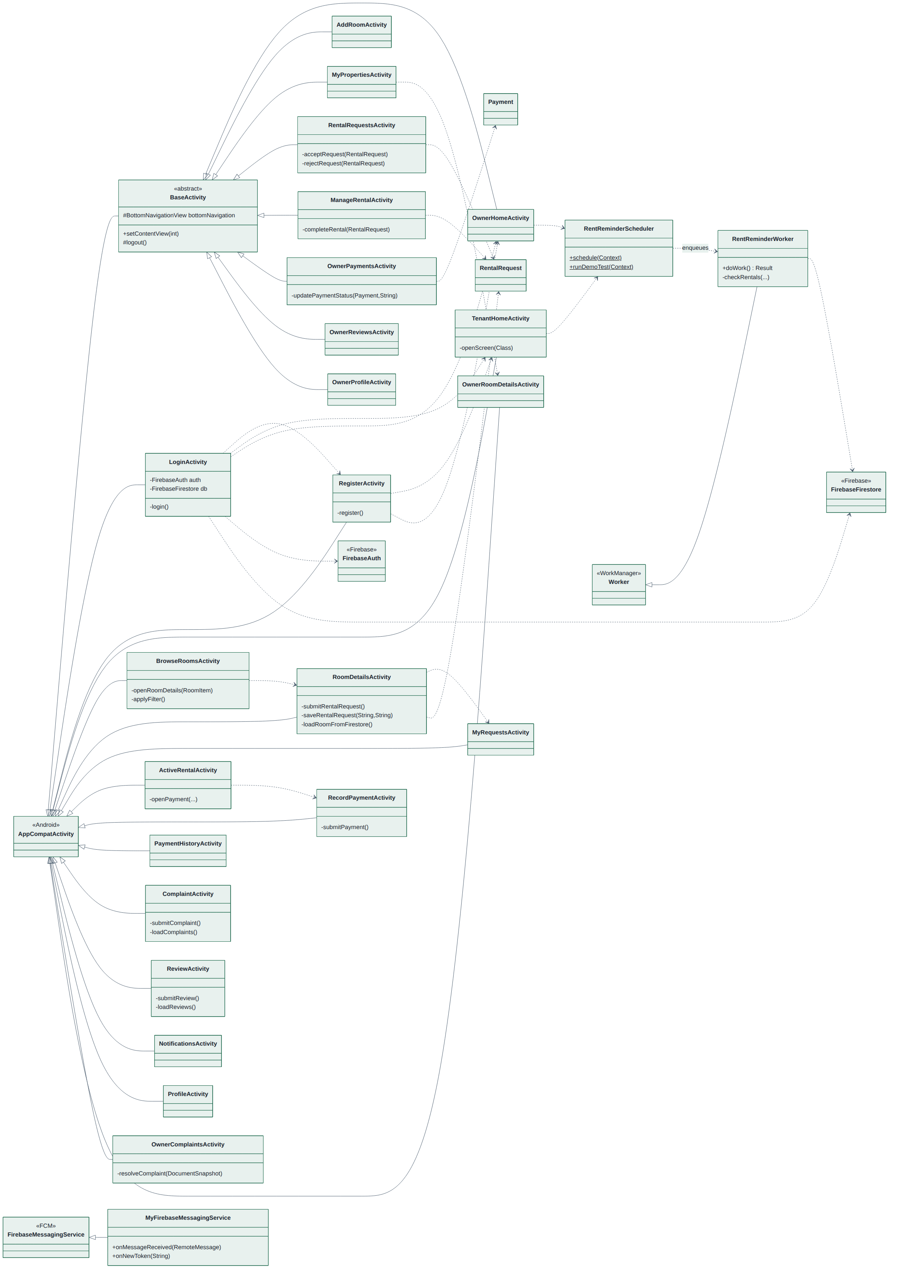
Figure: Class Diagram – Application Layer

5. Sequence Diagram – Registration and Login
Account creation with Firebase Authentication, profile storage in Firestore, and role-checked login.
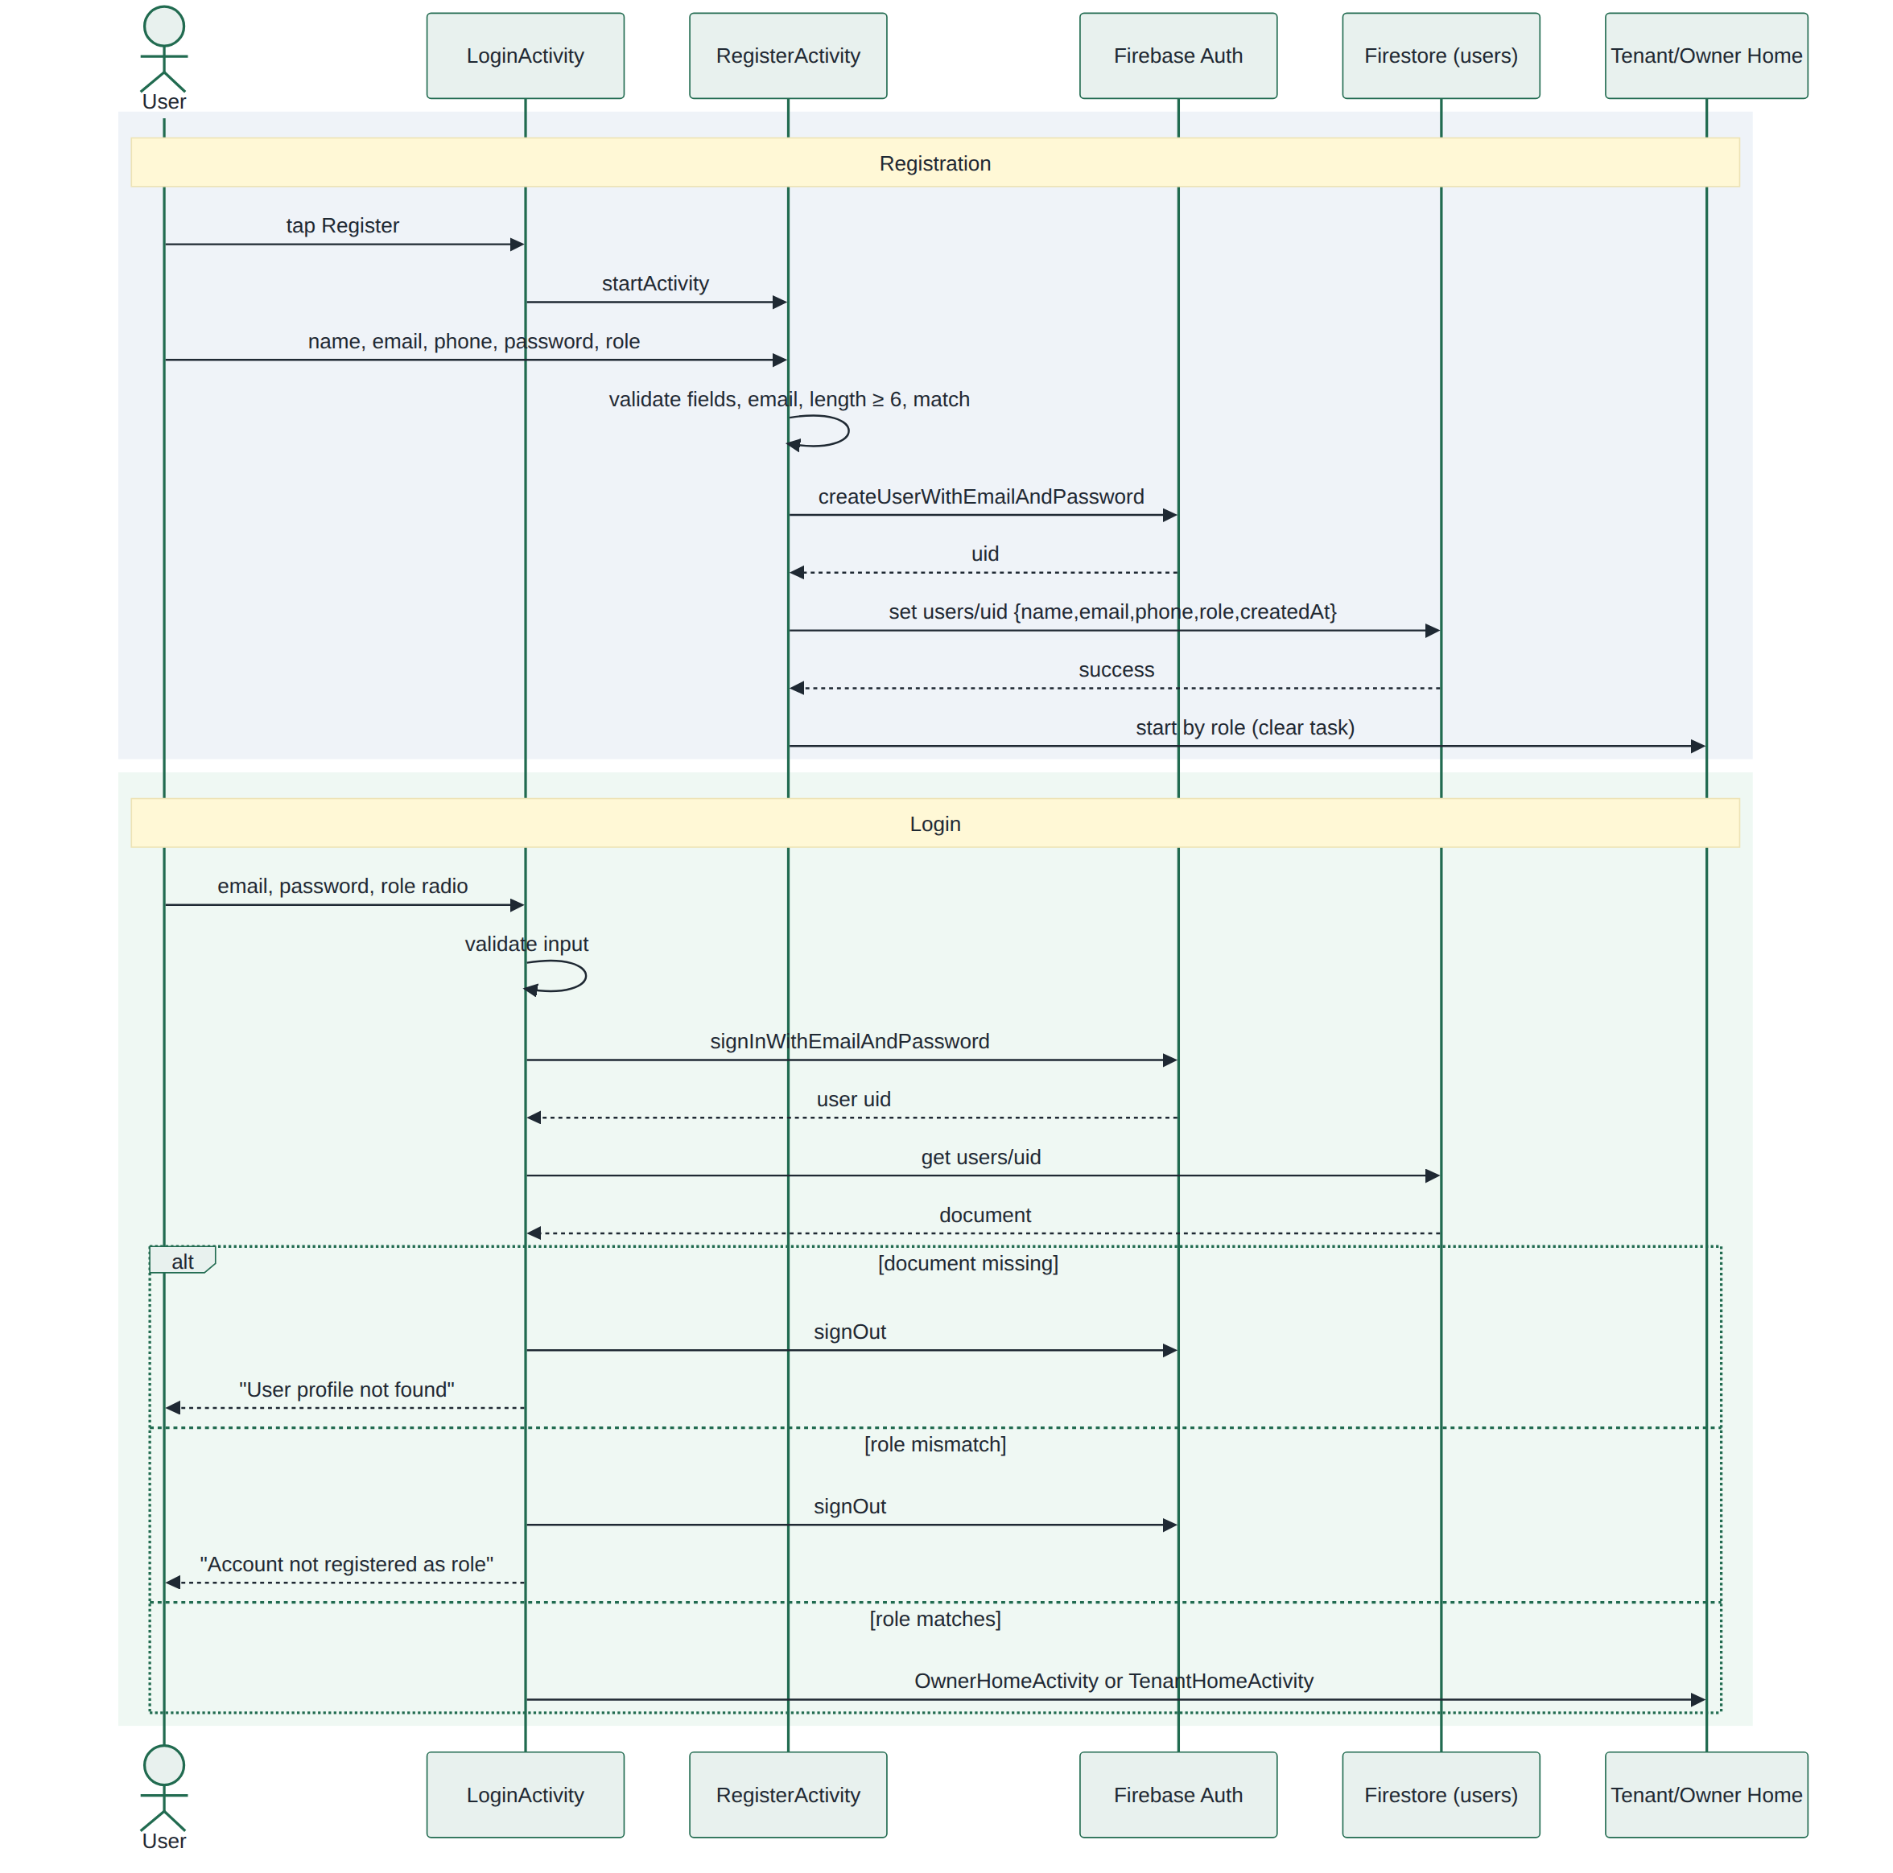
Figure: Sequence Diagram – Registration and Login

6. Sequence Diagram – Rental Request and Owner Approval
Tenant submits a request; the owner accepts (atomic batch write activating the rental and marking the room unavailable) or rejects.
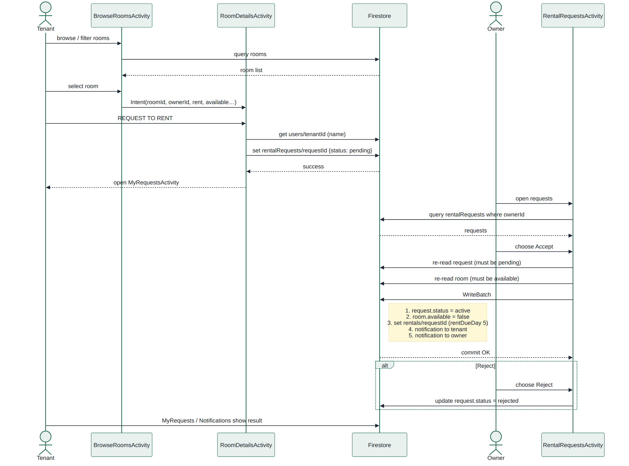
Figure: Sequence Diagram – Rental Request and Owner Approval

7. Sequence Diagram – Rent Payment and Verification
Tenant records a monthly payment; the owner verifies or rejects it and the tenant is notified.
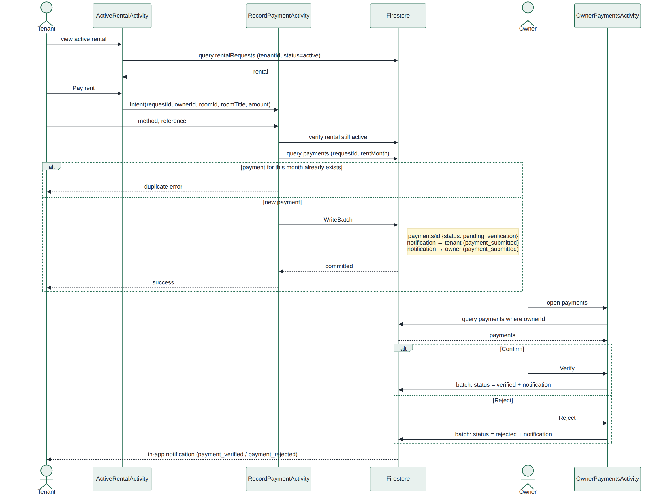
Figure: Sequence Diagram – Rent Payment and Verification

8. Sequence Diagram – Monthly Rent Reminder
Daily WorkManager job that creates rent reminders on days 1, 5 and 6 for unpaid rent.
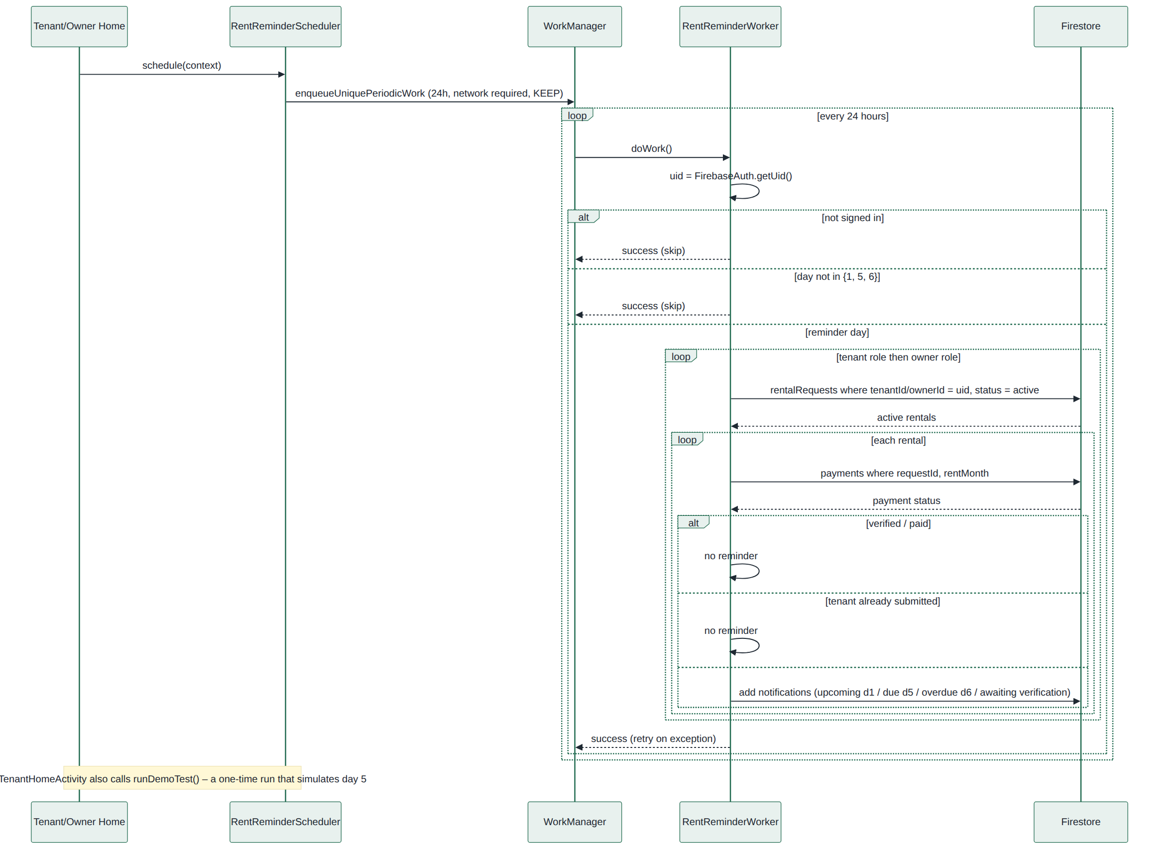
Figure: Sequence Diagram – Monthly Rent Reminder

9. Sequence Diagram – Complaint and Review
Tenant files complaints and reviews against the active rental; the owner resolves complaints and views reviews.
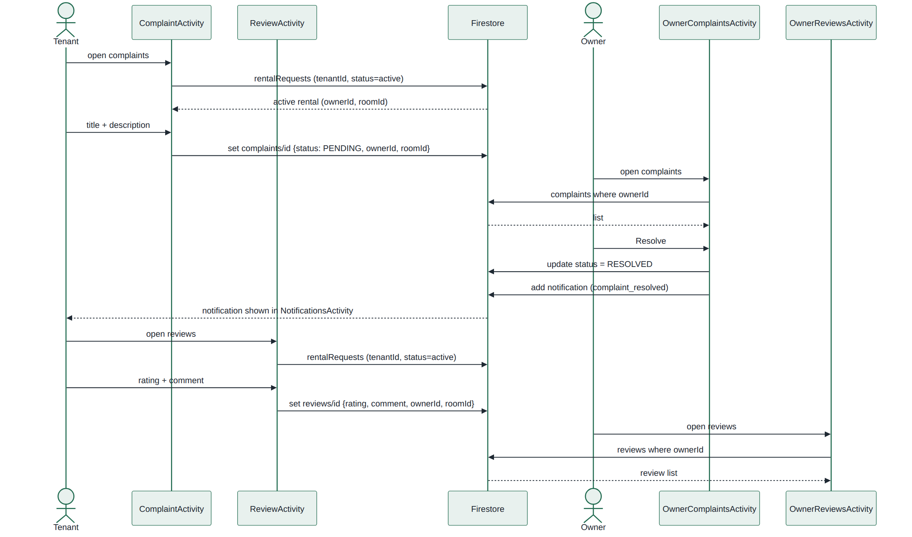
Figure: Sequence Diagram – Complaint and Review

10. Activity Diagram – Rental Lifecycle
End-to-end flow from listing a room to ending a rental.
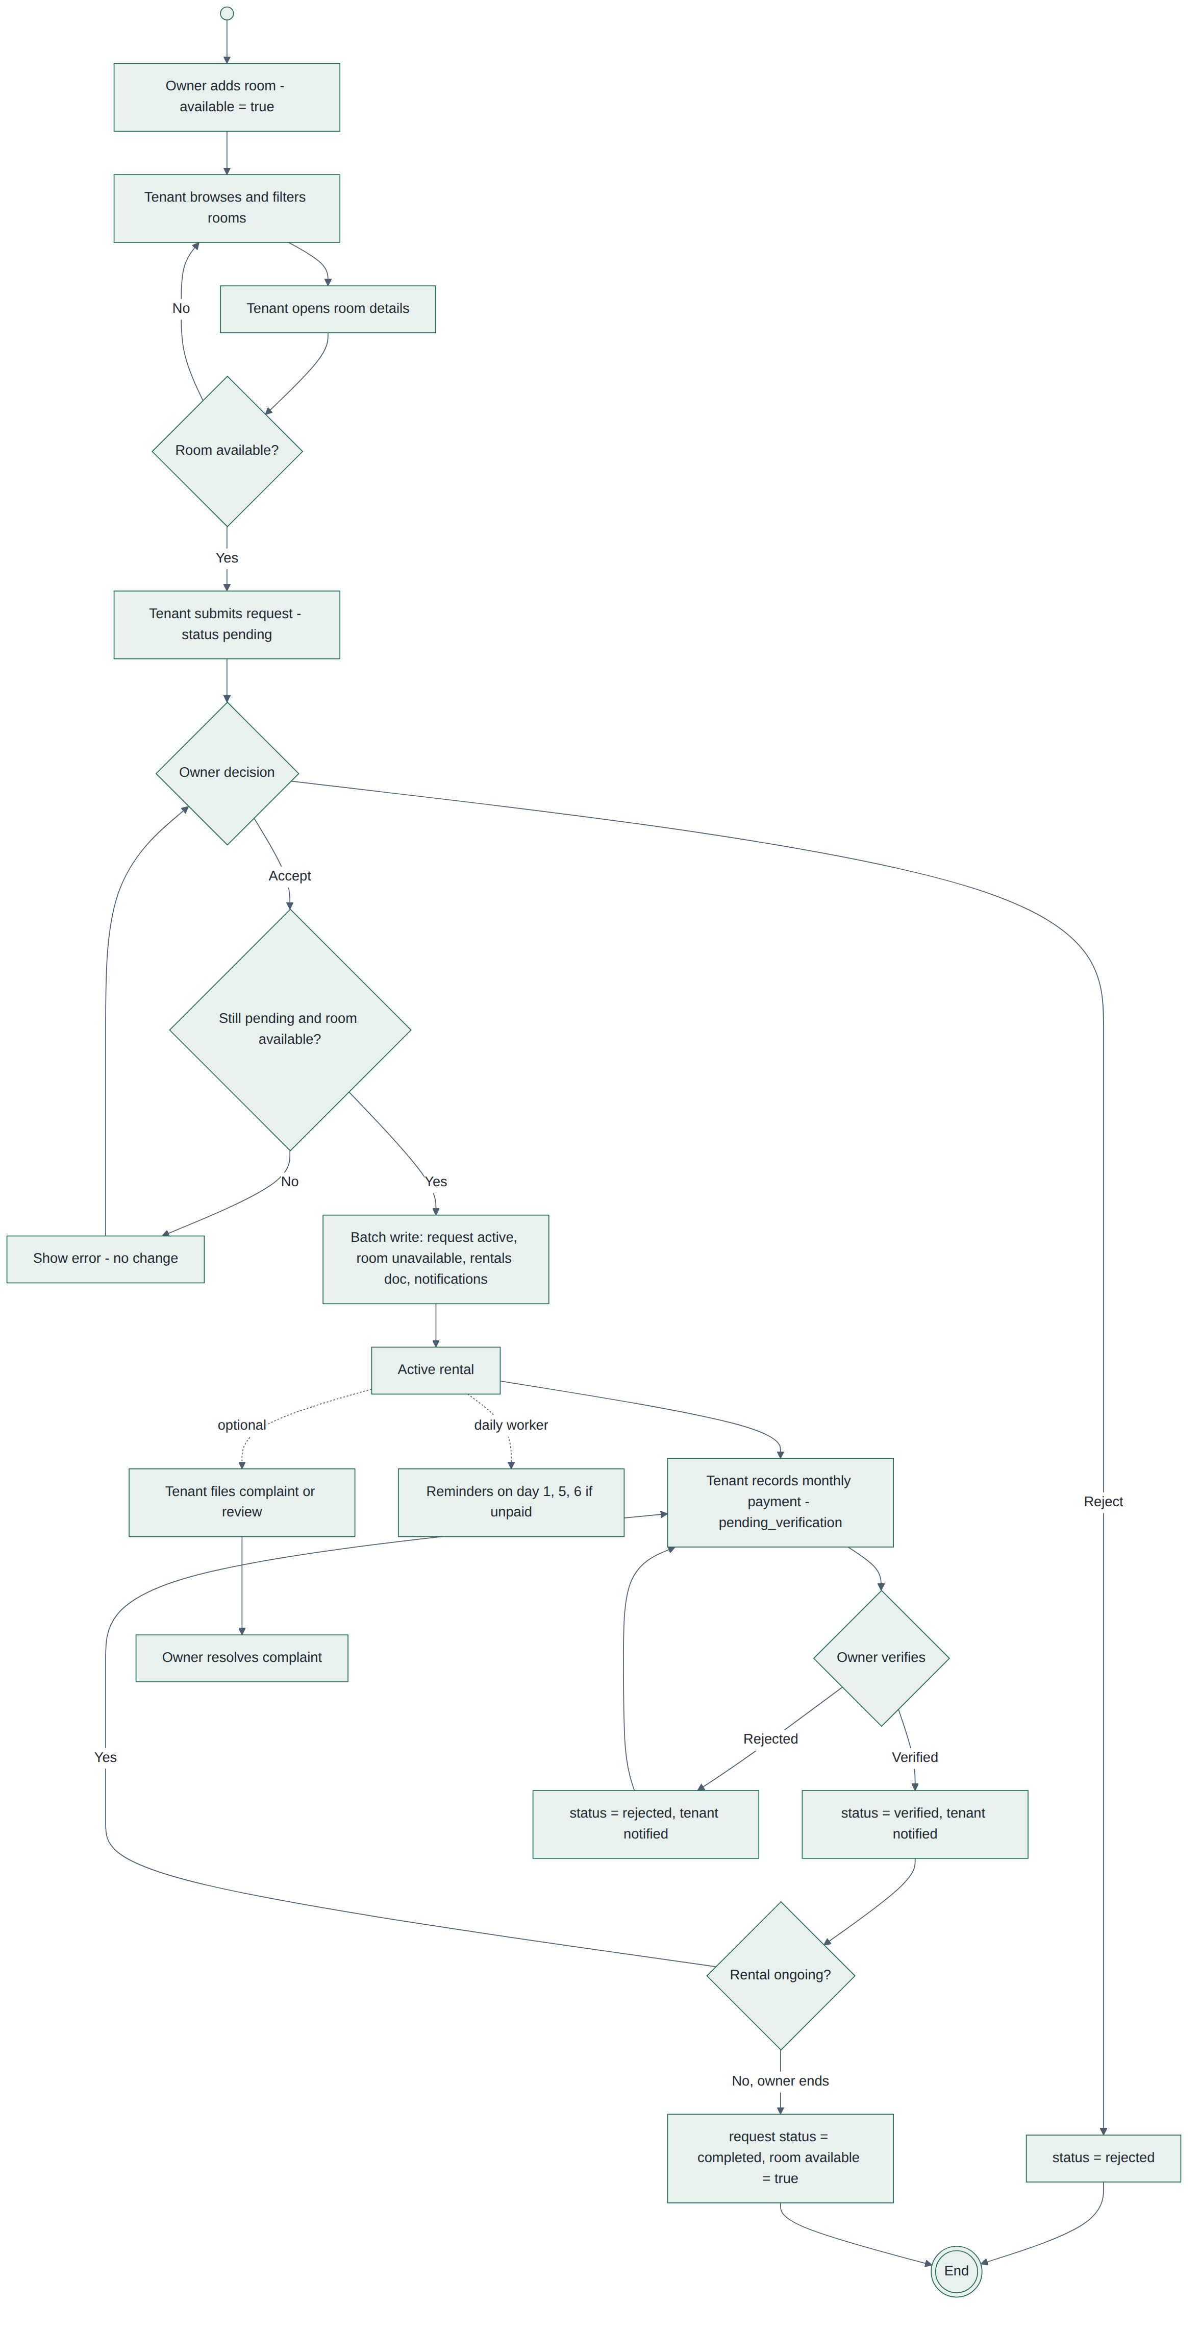
Figure: Activity Diagram – Rental Lifecycle

11. State Diagram – Rental Request
Status transitions of a rental request.
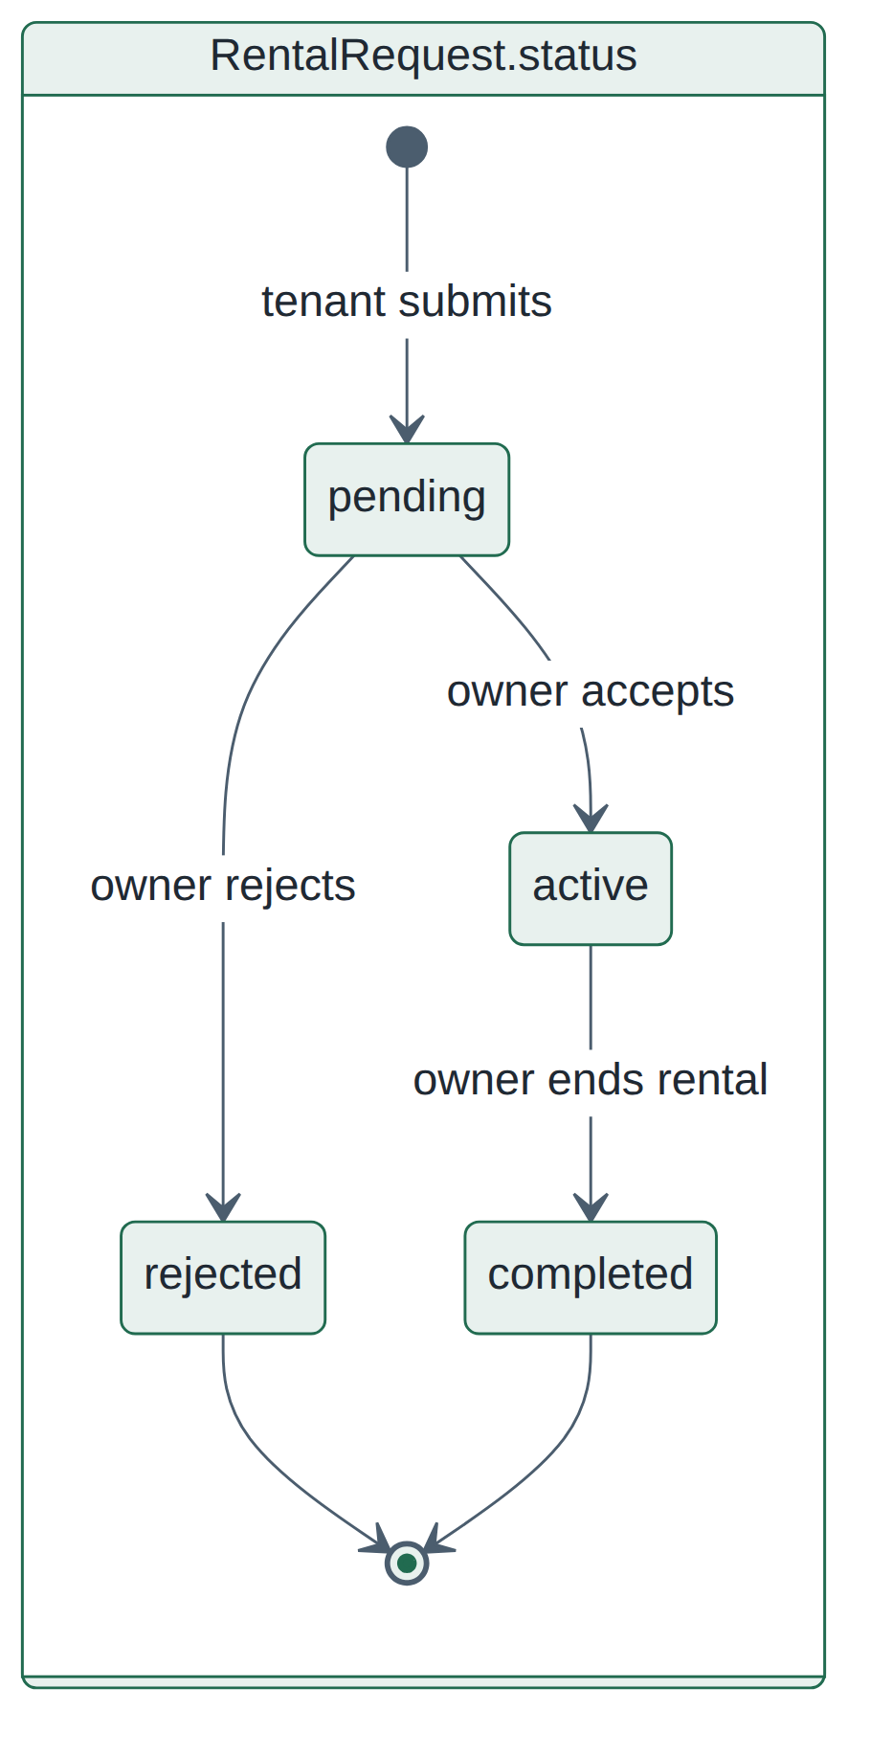
Figure: State Diagram – Rental Request

12. State Diagram – Payment
Status transitions of a rent payment.
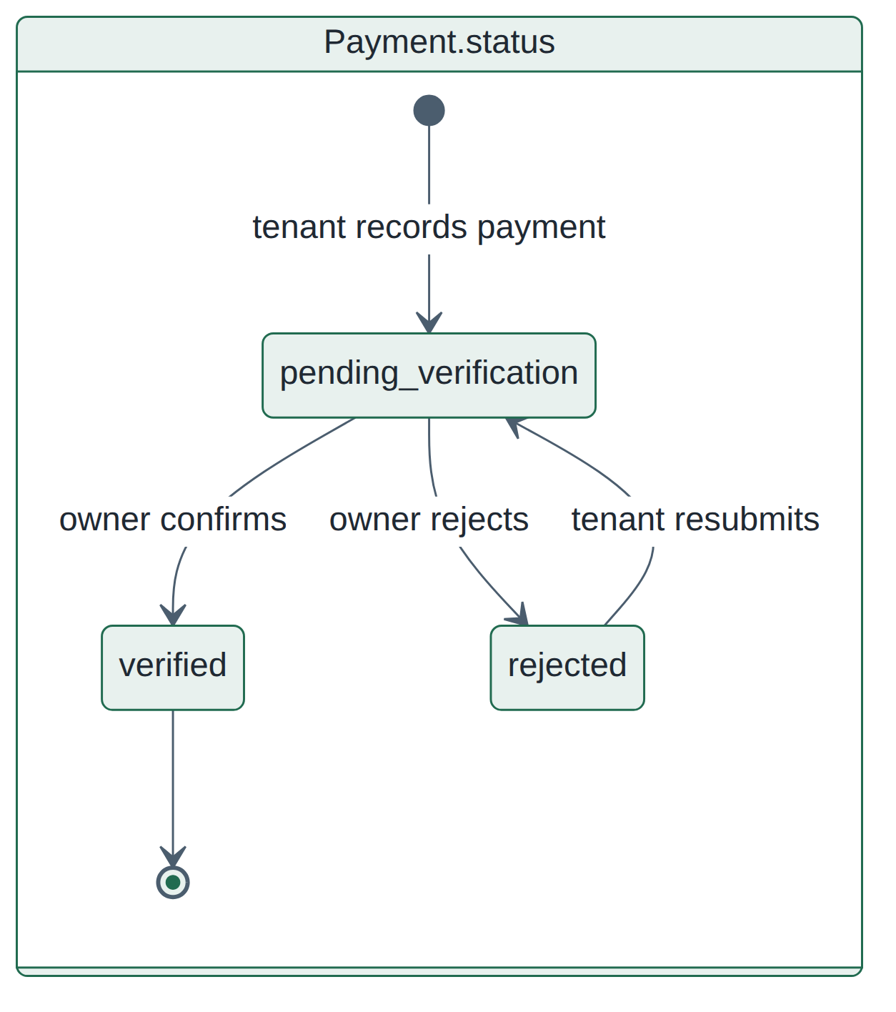
Figure: State Diagram – Payment

13. State Diagram – Complaint and Room Availability
Complaint status and room availability transitions.
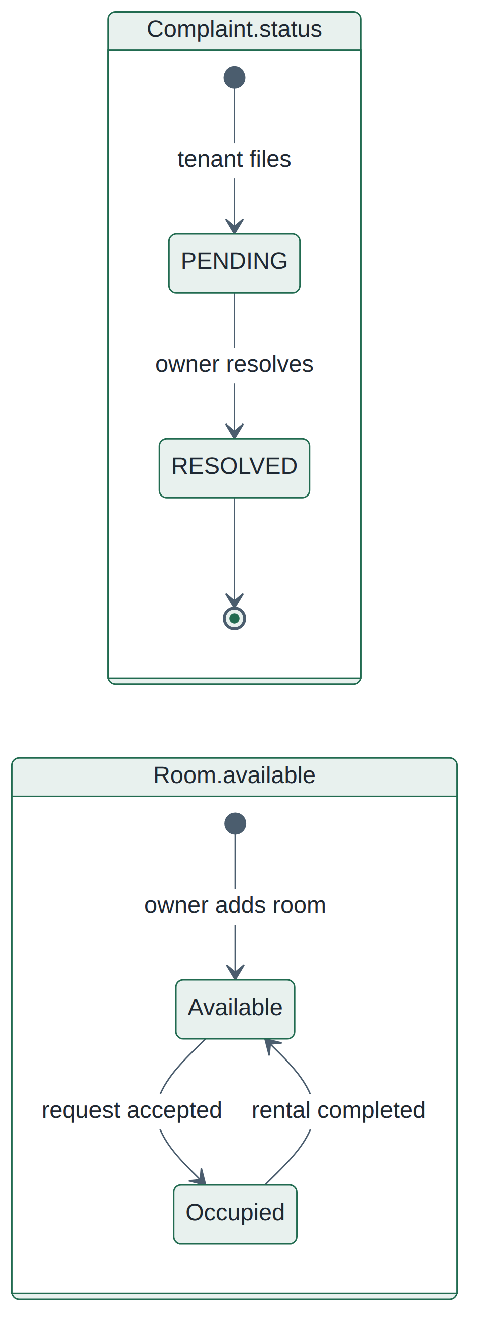
Figure: State Diagram – Complaint and Room Availability

14. ER Diagram – Firestore Collections
Collections, key fields and relationships (by stored IDs).
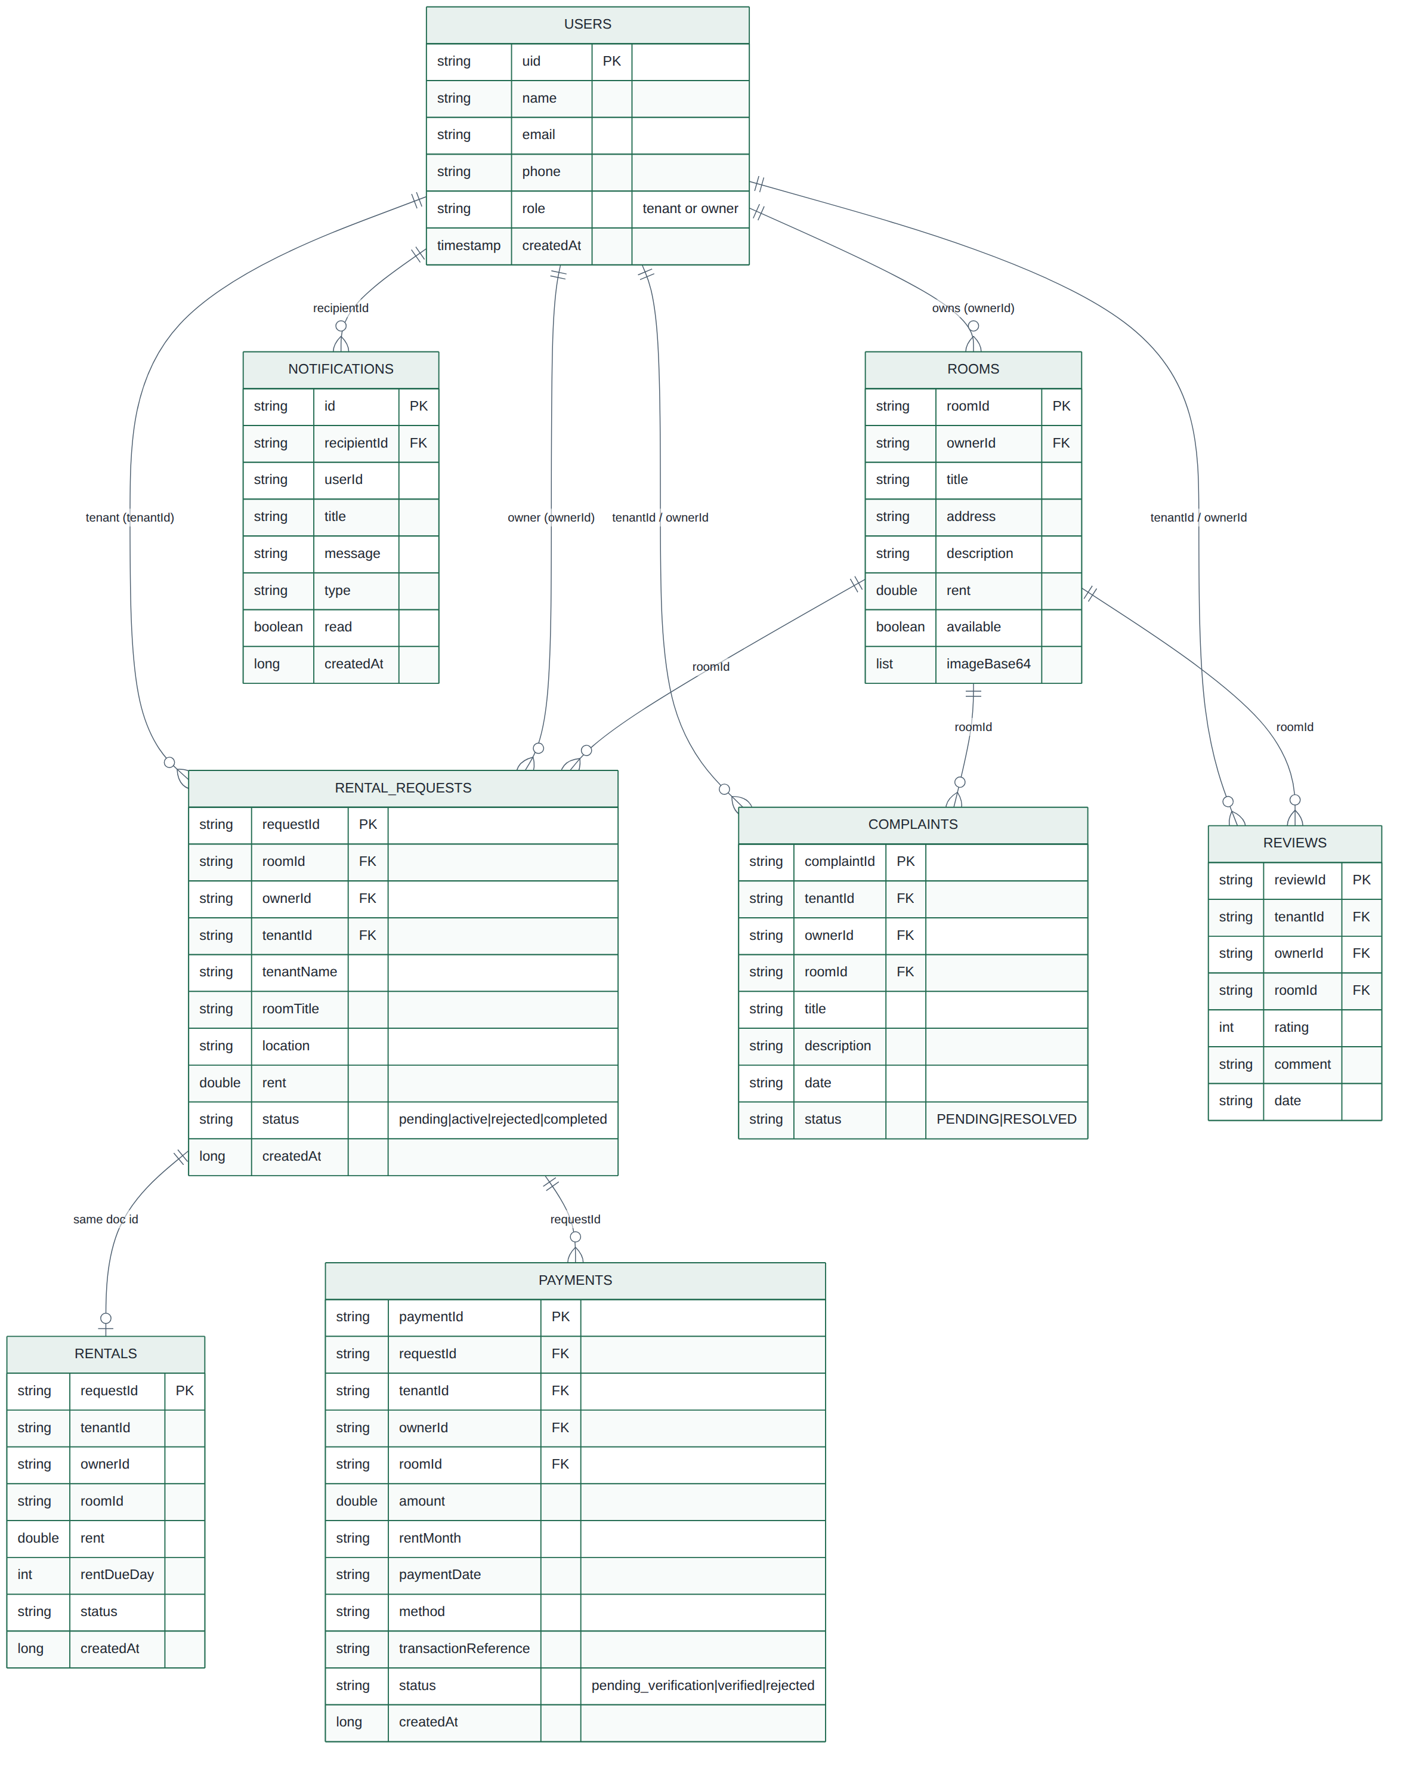
Figure: ER Diagram – Firestore Collections

15. Component Diagram
Application modules and their dependencies on Firebase services and WorkManager.
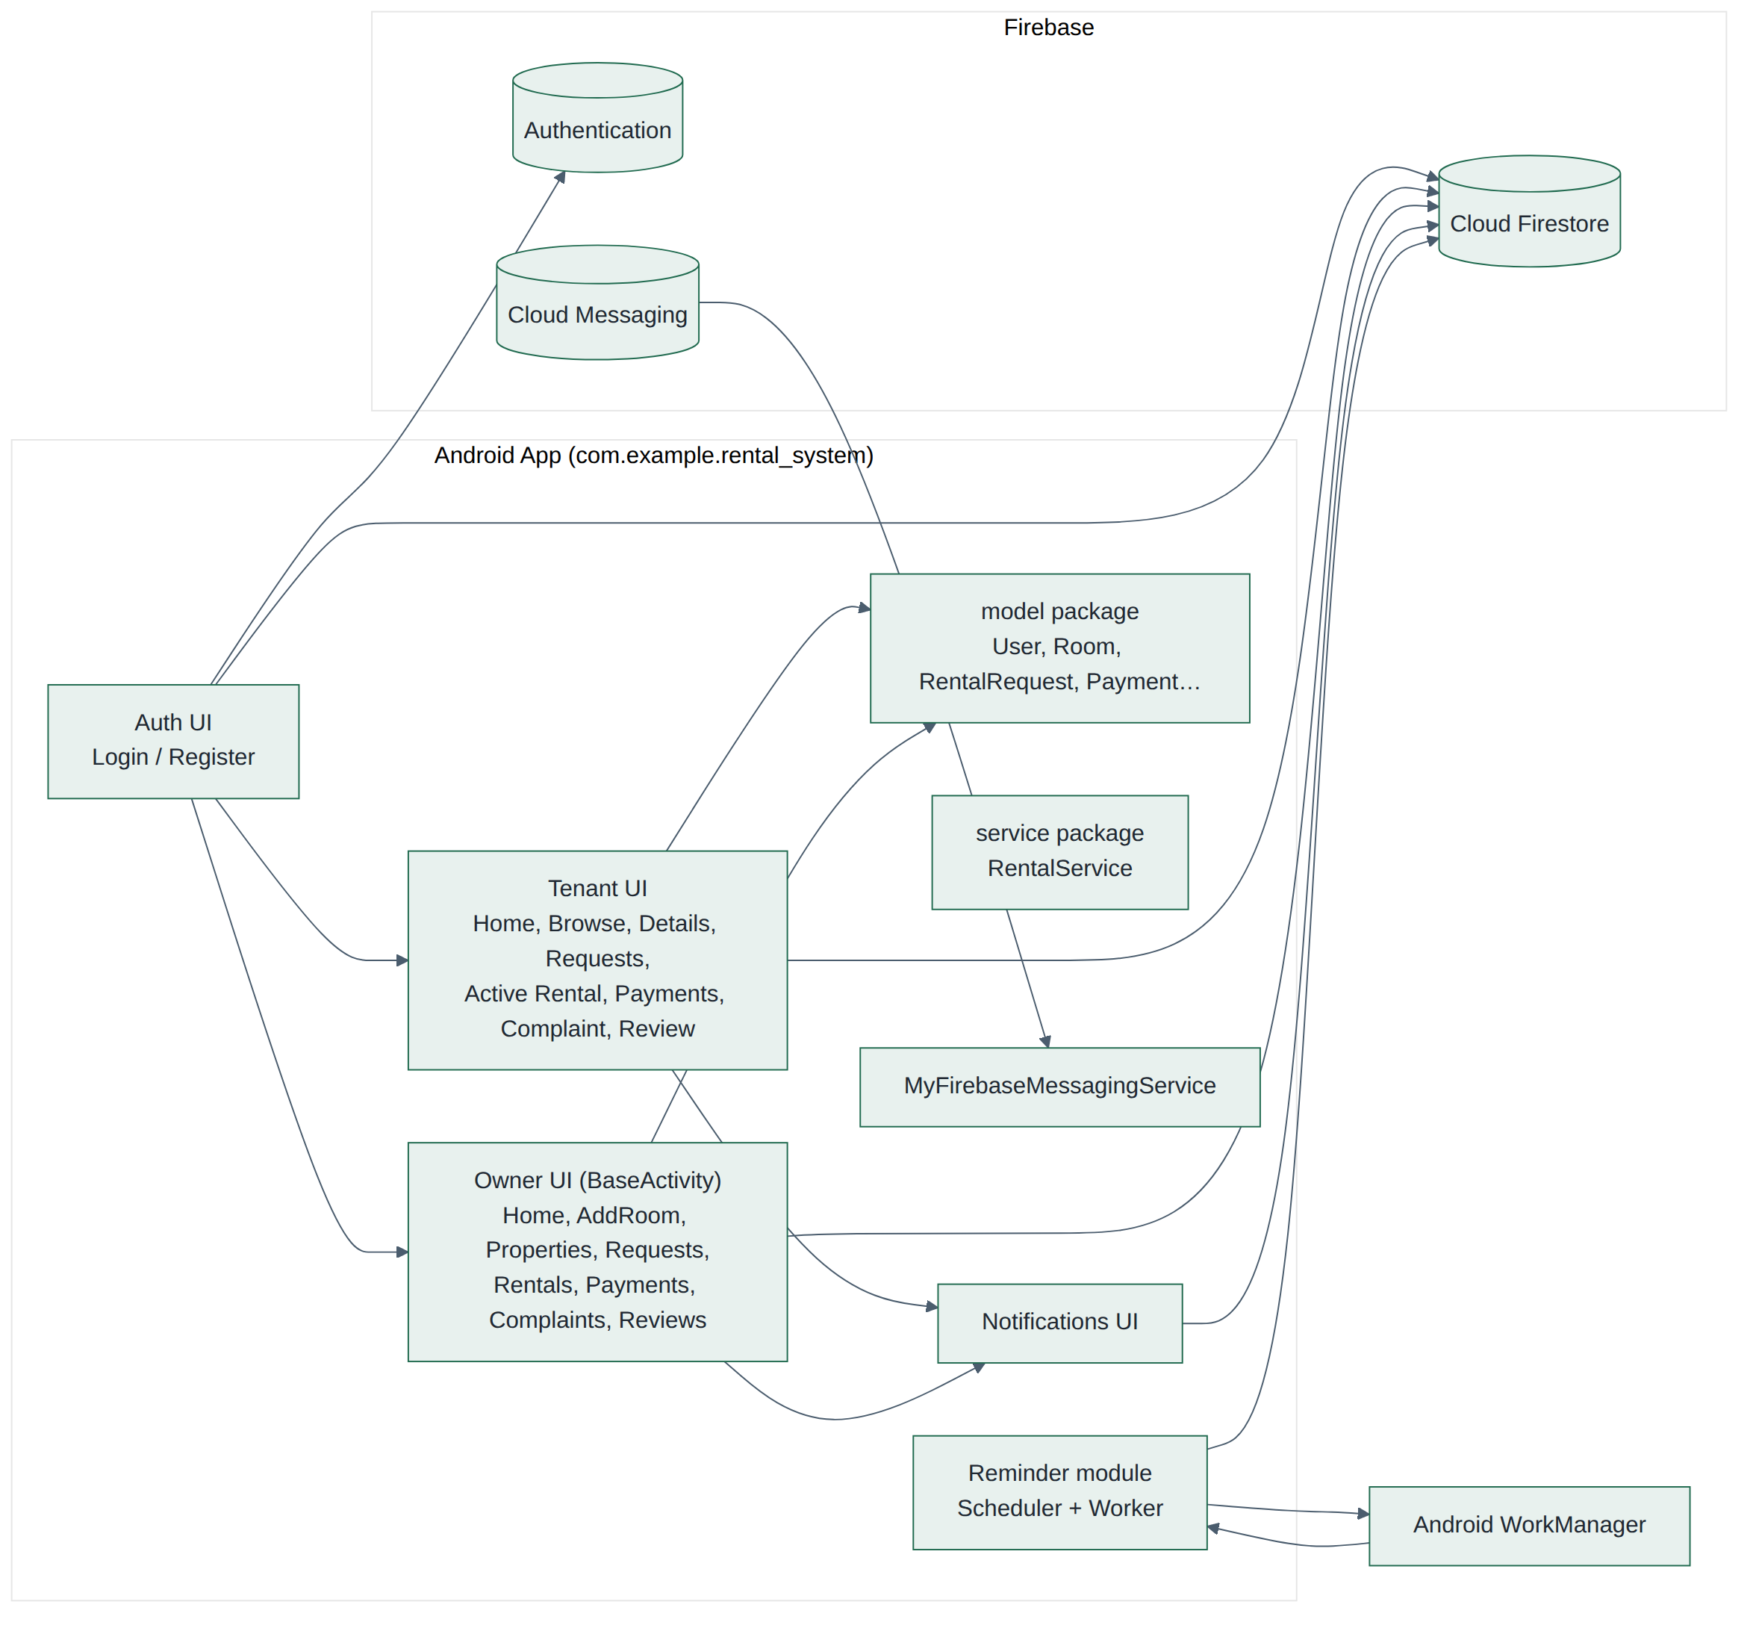
Figure: Component Diagram

16. Deployment Diagram
Android device communicating directly with Firebase cloud services.
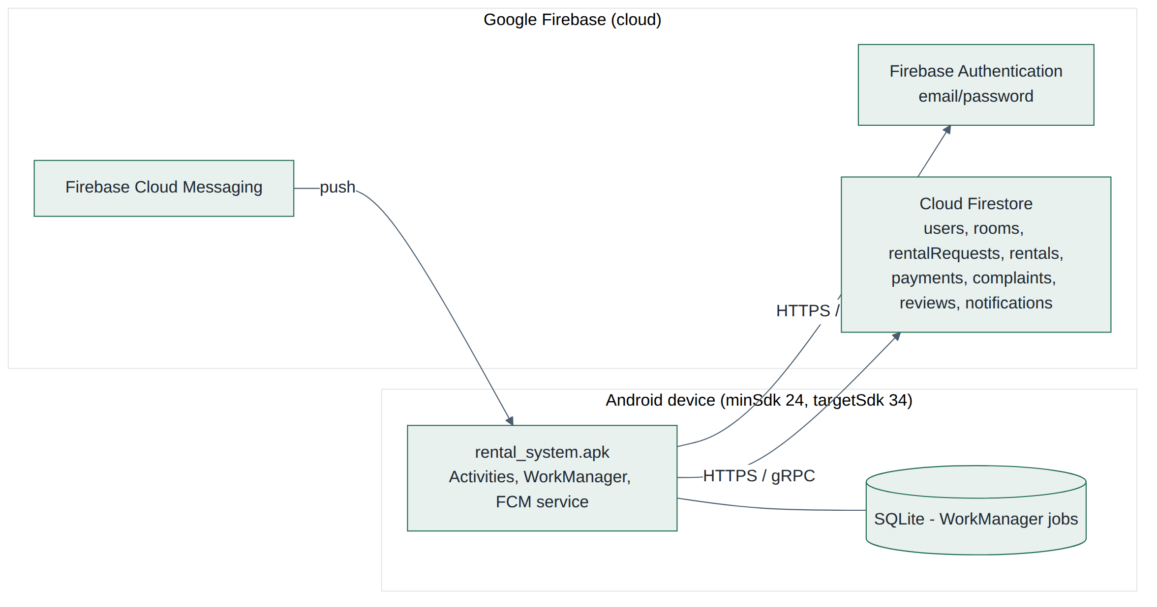
Figure: Deployment Diagram

17. Screen Navigation Diagram
Intent-based navigation between activities for tenant and owner flows.
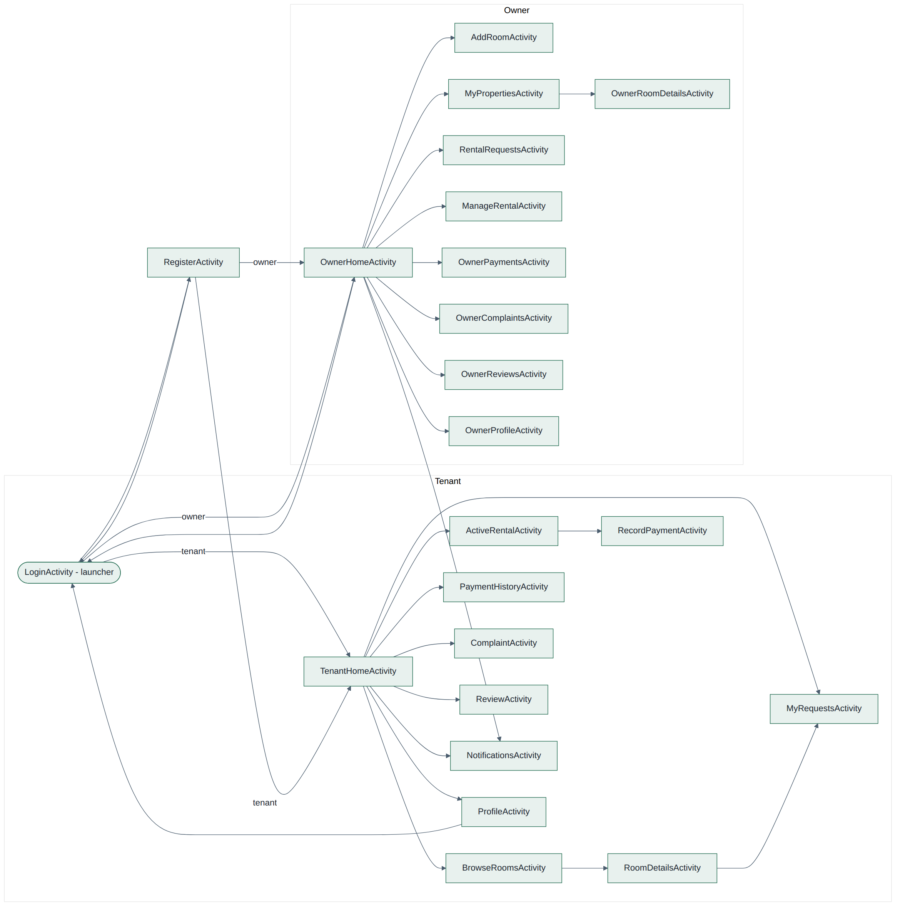
Figure: Screen Navigation Diagram

CHAPTER 11: DATABASE DESIGN
11.1 Overview
The application requires structured information for users, room listings, room requests, reviews, complaints, and payment reminders. If Firebase is used, these records may be stored in a cloud database.
The actual database structure must be taken from the project's Firebase collections or paths and data-access code. The structures below are logical models for documentation, not a claim that the database uses these exact field names.

11.2 User Records
A logical user record includes:
Field | Purpose
User ID | Unique user identifier
Name | Display name
Email | Account email
Phone | Contact number
Role | Tenant or Owner
Authentication is managed by Firebase Authentication integration

11.3 Room Records
A logical room record includes:
Field | Purpose
Room ID | Unique listing identifier
Owner ID | Reference to the owner
Title | Room listing title
Description | Room information
Location | Room location
Monthly Rent | Advertised monthly price
Availability | Availability information
Images | Room image references

11.4 Room Request Records
A room request may associate a tenant with a room and record the time of submission. A status field can represent states such as pending, accepted, or rejected if the application implements status management.

11.5 Review Records
A review may contain a reference to the room, the tenant who submitted it, review text, a rating if supported, and a creation timestamp.

11.6 Complaint Records
A complaint may contain a reference to the relevant room, the submitting tenant, the complaint description, and its submission time. A resolution status should be documented only if supported.

11.7 Payment Reminder Records
A reminder may contain a tenant identifier, reminder date, recurrence information, and enabled status. Depending on implementation, reminder configuration may be stored locally on the device or remotely.

11.8 Data Relationships
The logical relationships are:
- One owner may manage multiple room listings.
- A tenant may submit multiple room requests.
- A room may receive multiple requests.
- A room may be associated with multiple reviews.
- A room may be associated with multiple complaints.
- A tenant may configure a monthly payment notification.

11.9 Database Security
Database rules should ensure that authenticated users can access only the records permitted by their role. Owners should be prevented from editing another owner's room listings. Tenants should be prevented from altering another tenant's private profile or submitting modifications as another user.

CHAPTER 12: TENANT MODULE
12.1 Overview
The tenant module provides functionality for people searching for rental accommodation. It is designed to support the tenant's interaction with room listings and rental-related tasks.

12.2 Tenant Registration
The registration interface collects the information required to create an account. Input should be validated before the registration request is processed.
The system should communicate whether registration succeeds or fails and guide the user when required fields are missing or invalid.

12.3 Tenant Login
The login feature allows registered tenants to access their account. Authentication should be handled using the configured authentication service.
After successful login, the application should direct the tenant to the tenant interface and avoid granting owner-only access.

12.4 Room Search
Room search allows tenants to discover listings. The interface may accept a keyword or other search criteria supported by the application.
Results should provide enough information for tenants to compare available options.

12.5 Room Filtering
Filtering reduces the number of displayed listings according to selected criteria. Examples may include location, monthly rent, or other room attributes, but the final report should list only filters present in the actual application.
Search and filtering improve usability by helping tenants focus on relevant listings.

12.6 Room Details
The room-details interface allows a tenant to examine a selected listing before deciding whether to submit a request.
Information displayed should correspond to the room record stored in the system.

12.7 Room Request Submission
The tenant can submit a request for a selected room. The application should associate the request with the correct tenant and room.
A successful submission should provide confirmation. The report should clarify whether the current implementation includes request history, owner notifications, or acceptance and rejection functionality.

12.8 Tenant Profile Management
The tenant can edit supported profile information. The application should validate input and save changes to the appropriate data source.
The interface should distinguish between profile information and authentication credentials.

12.9 Reviews
The review feature allows tenants to share feedback about their rental experience. Reviews can help provide information to owners and potentially help future tenants make informed decisions.
The system should associate each review with the correct user and room and apply appropriate access rules.

12.10 Complaints
The complaint feature gives tenants a structured way to describe a room-related issue. A complaint should be associated with the relevant room and submitting tenant.
The report should not claim automated resolution or administrative escalation unless those capabilities exist in the application.

12.11 Monthly Payment Reminder
The payment reminder feature helps tenants remember recurring rent due dates. Tenants should be able to configure a monthly reminder using the controls provided by the application.
The actual reminder mechanism may depend on Android scheduling, notification permissions, device settings, and the implementation used in the source code.

CHAPTER 13: OWNER MODULE
13.1 Overview
The owner module allows property owners to maintain their accounts and manage their rental room information.

13.2 Owner Registration
The registration process creates an owner account using the information required by the application. The account must be associated with the owner role so that the appropriate interface and permissions are applied.

13.3 Owner Login
The login function authenticates the owner and opens the owner interface after successful authentication.
Role checks and backend permissions should ensure that tenant accounts cannot perform owner-only operations.

13.4 Adding a Room
The owner can enter the details of a room and submit a new listing. The application should validate required fields and confirm whether the record was saved successfully.
The report should include the actual room fields and image-upload behavior supported by the source code.

13.5 Editing Room Details
The owner can update information associated with an existing listing. The application should verify that the selected listing belongs to the logged-in owner.
Changes should be reflected in the data source and displayed consistently when the listing is reopened.

13.6 Owner Profile Management
The owner can edit supported profile information. Profile updates should be saved to the appropriate record without changing unrelated user data.

13.7 Viewing Reviews
The owner can access reviews related to their room listings. This functionality helps owners understand tenant feedback and identify potential improvements.
Access rules should prevent owners from viewing unrelated private records unless the application explicitly permits such access.

13.8 Viewing Complaints
The owner can access complaints associated with their room listings. This allows them to review issues reported by tenants.
The feature supports visibility of complaints but should not be described as a full complaint-resolution workflow unless status tracking and resolution functionality are implemented.

13.9 Owner Module Benefits
The owner module centralizes room information, reduces repetitive listing maintenance, and makes room-related feedback more accessible.

CHAPTER 14: ROOM REQUESTS, REVIEWS, AND COMPLAINTS
14.1 Room Request Management
Room requests represent tenant interest in a particular listing. The request record should preserve the association between the tenant and the selected room.
The system should prevent missing or invalid references and display clear feedback after submission.

14.2 Review Management
Reviews provide feedback about a rental room or experience. The interface should make the review submission process straightforward and validate any required fields.
If the application supports ratings, the permitted rating range and validation should be documented.

14.3 Complaint Management
Complaints allow tenants to record problems related to a room. A clear description helps the owner understand the reported issue.
The application should associate complaints with the correct listing and user. Sensitive personal information should not be exposed unnecessarily.

14.4 Data Access and Privacy
Only authorized users should be able to access or modify the relevant records. Client-side interface restrictions should be supported by backend or database security rules.

14.5 Possible Improvements
Potential improvements include request-status tracking, owner responses, complaint-resolution status, review moderation, and notifications. These should be identified as future work unless already implemented.

CHAPTER 15: MONTHLY PAYMENT NOTIFICATION
15.1 Introduction
Monthly rent is a recurring financial obligation. Remembering the due date can be difficult when users manage multiple monthly commitments.
The Rental Room Management System includes a payment reminder feature intended to help tenants remember their configured payment dates.

15.2 Functional Description
A typical reminder workflow consists of:
- The tenant opens the reminder feature.
- The tenant selects a reminder date or day of the month.
- The tenant configures any available reminder time or options.
- The application saves the configuration.
- The reminder mechanism schedules the notification.
- The tenant receives a notification when the scheduled reminder is triggered, subject to device and application settings.
This workflow should be adjusted to match the actual implementation.

15.3 Android Notification Considerations
Reliable reminders may require local scheduling through Android APIs, notification channels, and notification permissions. Exact alarm restrictions and background-execution behavior vary by Android version and implementation.
If the application uses a simple date stored in the database without scheduling notifications, the report must not claim that automatic notifications are delivered.

15.4 Benefits
- Helps tenants remember rental payment dates.
- Provides a recurring reminder mechanism if correctly scheduled.
- Improves convenience by bringing a rental-related task into the same application.

15.5 Limitations
A reminder is not the same as an actual payment transaction. Unless payment processing is implemented, the application does not itself transfer rent, confirm receipt of payment, or guarantee that a tenant pays on time.

CHAPTER 16: IMPLEMENTATION DETAILS
16.1 Development Approach
The application can be described using an iterative development approach in which features are implemented and tested in stages.
A suitable sequence is:
- Establish the Android project.
- Implement registration and login.
- Separate tenant and owner functionality.
- Develop room listing management.
- Implement room searching and filtering.
- Add requests, reviews, and complaints.
- Implement monthly reminders.
- Integrate the backend and database.
- Test the combined application.
- Prepare documentation and screenshots.
This is a recommended description of the development workflow; actual dates and activities should be adjusted to the work performed by the team.

16.2 Android Application
Java is used to implement Android-side functionality. Android activities and layout resources provide the interface through which users interact with the system.
The final report should identify the actual activity classes, layout files, adapters, models, and utility classes found in the source code.

16.3 Firebase Integration
Where configured, Firebase services can support account authentication and cloud data storage. Authentication and database operations should be handled consistently with the application's role model.
The report should specify the actual Firebase products used rather than listing services merely because they are available.

16.4 Input Validation and Error Handling
Input validation helps prevent incomplete or invalid data from being submitted. Error handling should account for network failures, invalid credentials, denied database operations, and unsuccessful saves.
The user should receive a meaningful message rather than an unexplained failure.

16.5 AI-Assisted Chat Functionality
If the submitted project includes the separately added AI chatbot, it should be documented as an additional feature. A typical implementation uses an Android chat interface and a backend service that communicates with an AI provider.
API credentials must remain on the backend rather than being embedded in the Android application. The backend should authenticate users, validate input, and apply appropriate usage controls.
If the version submitted for evaluation does not include a working chatbot or configured backend, this section should instead be labelled as a proposed enhancement or removed.

16.6 Configuration and Deployment
Backend endpoints, service credentials, and other environment-specific settings should be configured outside public source code. Production services should use HTTPS and suitable access controls.

CHAPTER 17: TESTING AND VALIDATION
17.1 Introduction
Testing is necessary to check that the application's features behave as intended and that invalid operations are handled appropriately.
The final submission should include actual test results from the running application. The cases below are a proposed test plan, not a claim that every test has already passed.

17.2 Functional Test Cases
Test ID | Test scenario | Expected result
TC-01 | Register a tenant with valid details | Tenant account is created
TC-02 | Register an owner with valid details | Owner account is created
TC-03 | Log in using valid credentials | Correct user interface opens
TC-04 | Submit invalid login details | Error message is displayed
TC-05 | Owner adds a room with valid details | Listing is saved
TC-06 | Owner edits an existing room | Updated details are saved
TC-07 | Tenant searches for rooms | Matching results are displayed
TC-08 | Tenant applies a supported filter | Results reflect the selected filter
TC-09 | Tenant submits a room request | Request is recorded or an error is shown
TC-10 | Tenant updates profile details | Changes are saved
TC-11 | Tenant submits a review | Review is recorded if input is valid
TC-12 | Tenant submits a complaint | Complaint is recorded if input is valid
TC-13 | Owner opens relevant reviews | Authorized reviews are displayed
TC-14 | Owner opens relevant complaints | Authorized complaints are displayed
TC-15 | Tenant configures a reminder | Reminder settings are saved
TC-16 | User submits incomplete form data | Validation message is displayed
TC-17 | User attempts an unauthorized operation | Access is denied
TC-18 | Network connection is unavailable | Failure is handled without application crash

17.3 Testing Types
Unit testing: Checks individual functions and validation logic.
Integration testing: Checks communication between the Android interface, authentication, and database services.
System testing: Checks the combined application from the user's perspective.
Usability testing: Evaluates whether tenants and owners can understand and use the available features.
Security testing: Checks account isolation, room ownership permissions, and access to private data.

CHAPTER 18: RESULTS AND DISCUSSION
18.1 Expected System Outcome
The intended outcome is an Android application that supports the principal activities of room rental management through tenant and owner accounts.
The tenant interface supports room discovery, requests, profile editing, reviews, complaints, and payment reminders. The owner interface supports room listing management, profile editing, and access to room-related feedback.

18.2 Evaluation Criteria
- Correct account creation and authentication.
- Correct separation of tenant and owner functions.
- Accurate room listing creation and editing.
- Correct search and filter behavior.
- Correct association of requests, reviews, and complaints.
- Reliable saving of profile information.
- Correct scheduling and delivery of reminders, where implemented.
- Appropriate handling of invalid input and service failures.

18.3 Screenshots of the Developed Application
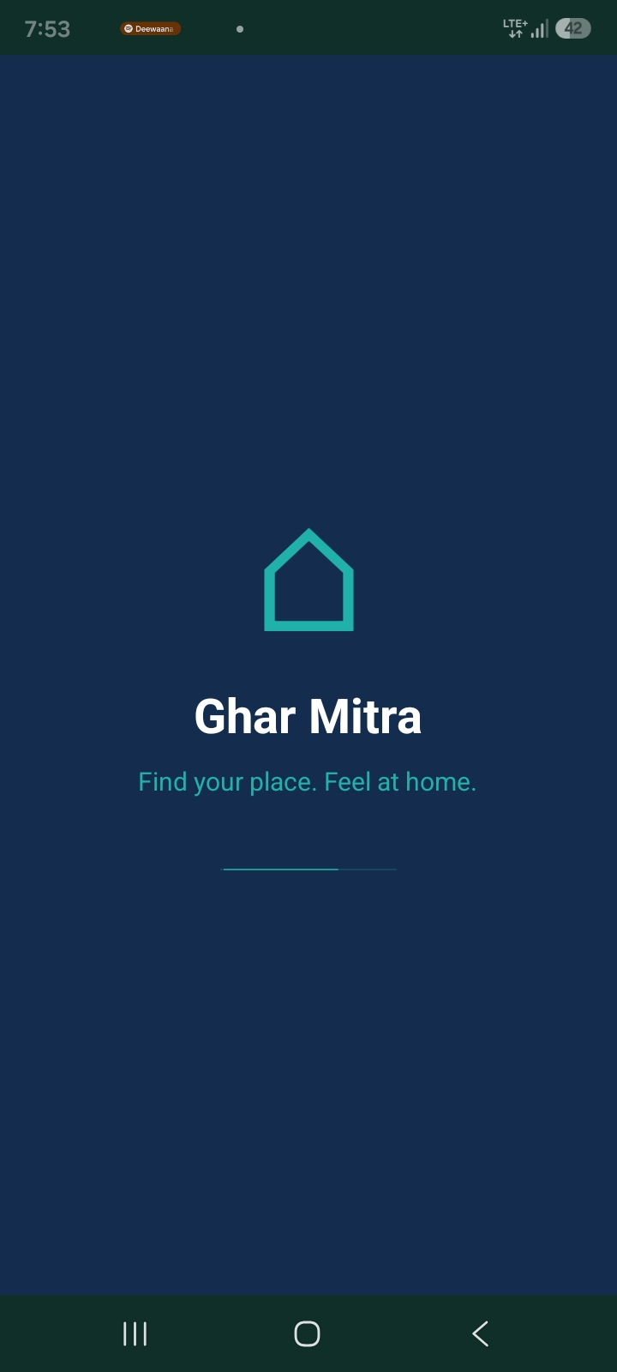
- Application launch.

- User registration screen.
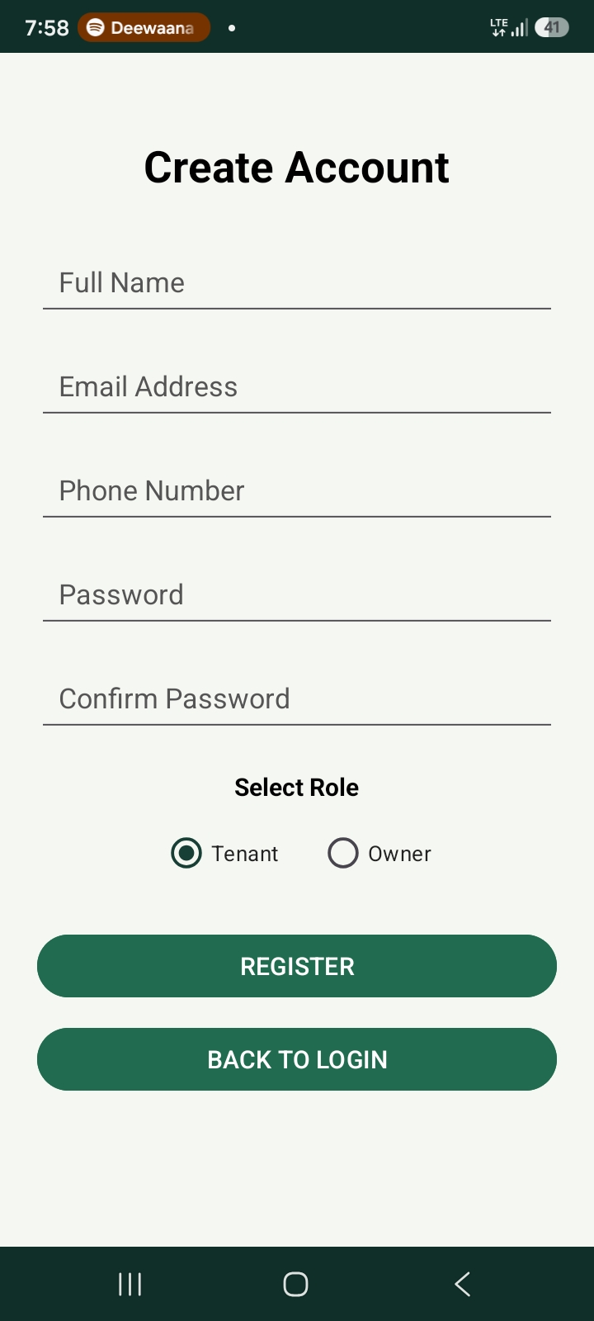
- Login screen.
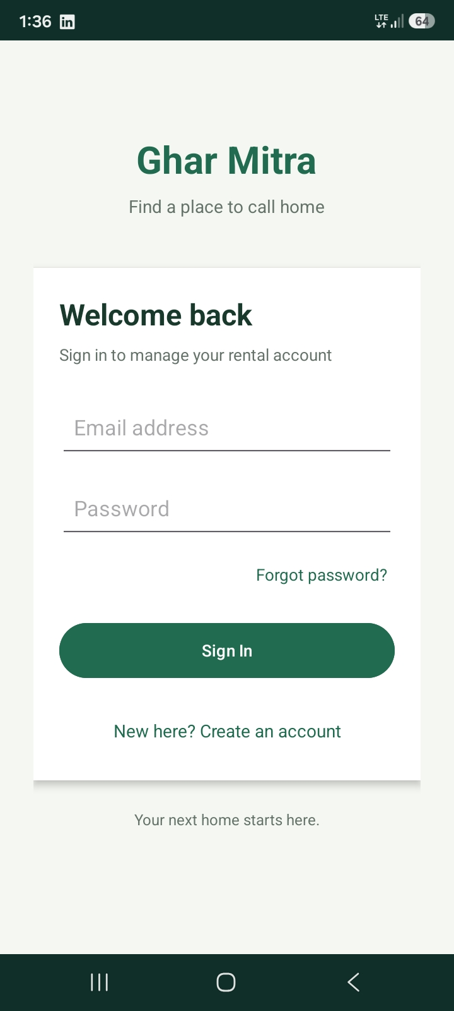
- Tenant dashboard.
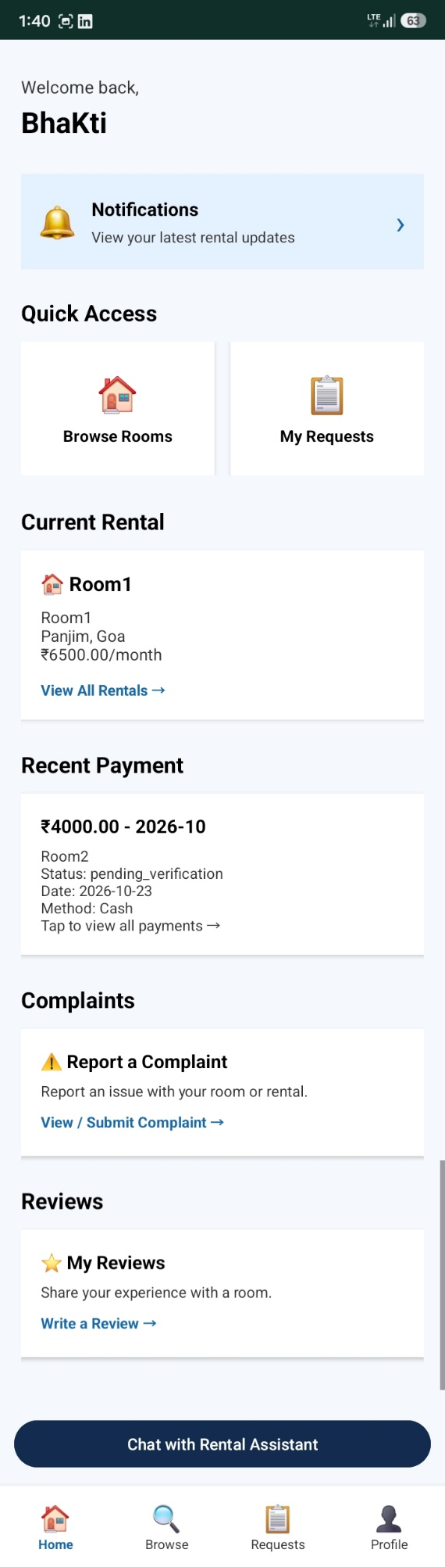
- Owner dashboard.
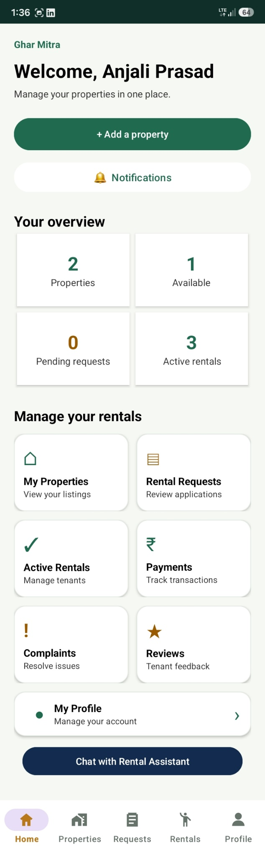
- Room search screen.
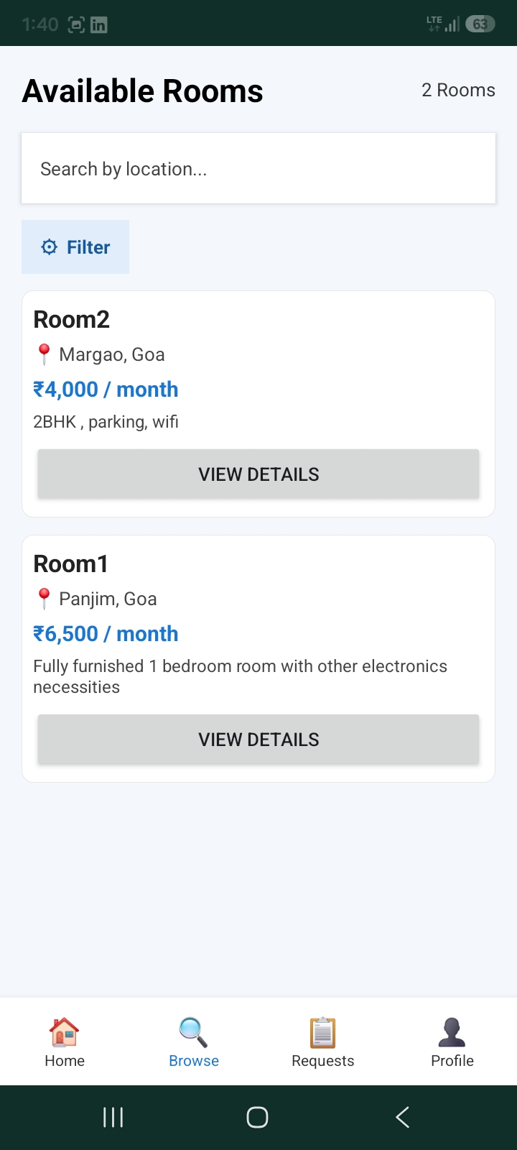
- Room filter screen.
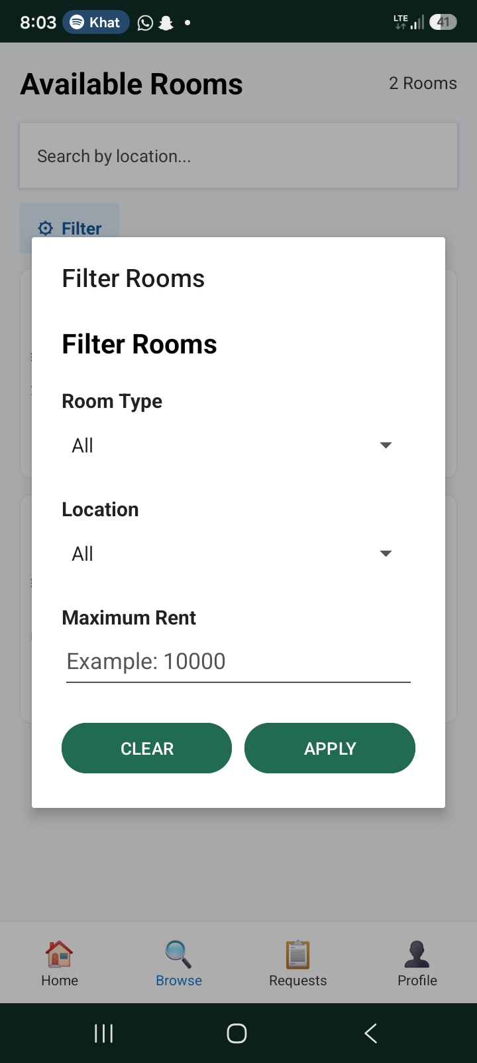
- Room details screen.
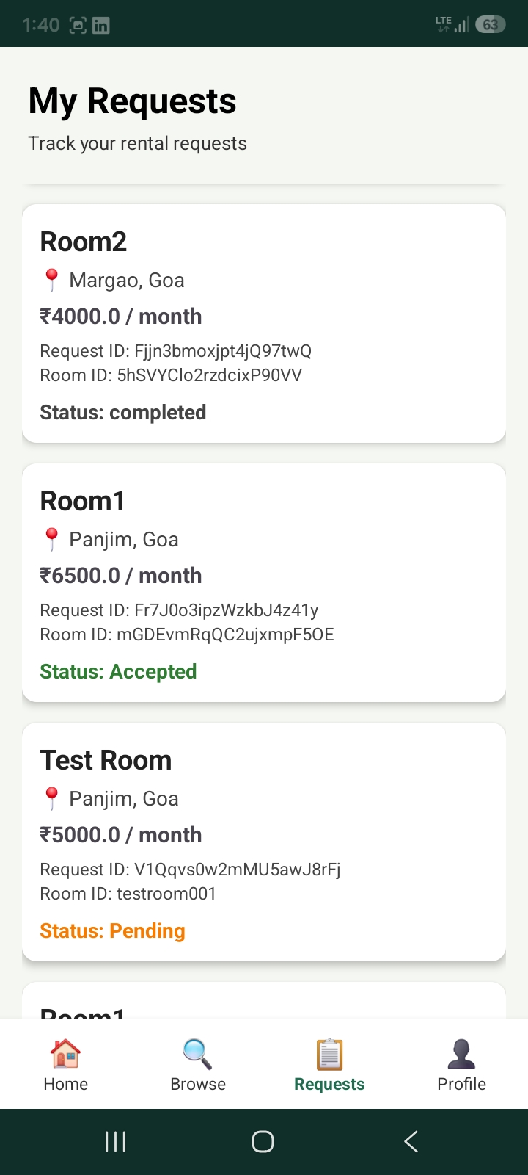
- Add room screen.
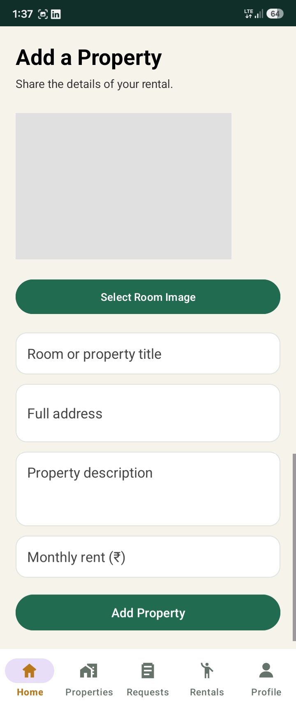
- Edit room screen.
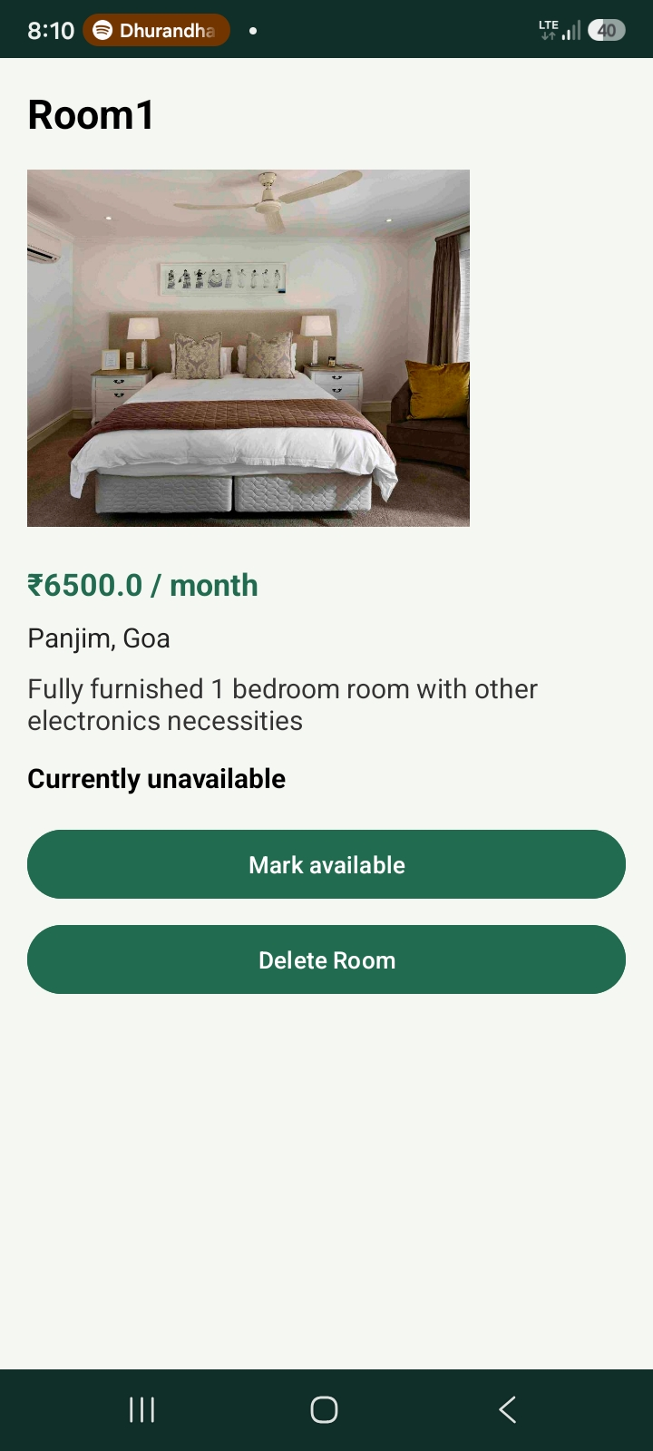
- Tenant profile screen.
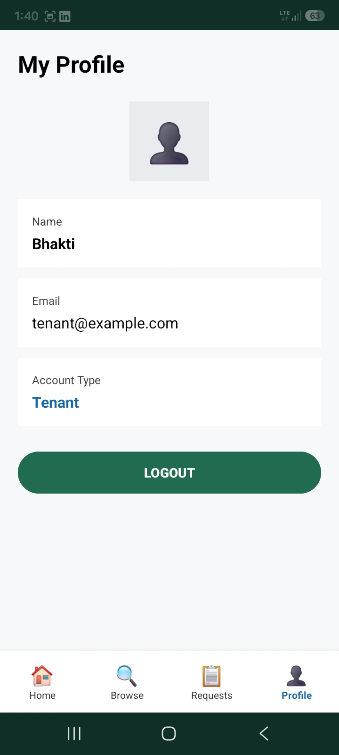
- Owner profile screen.
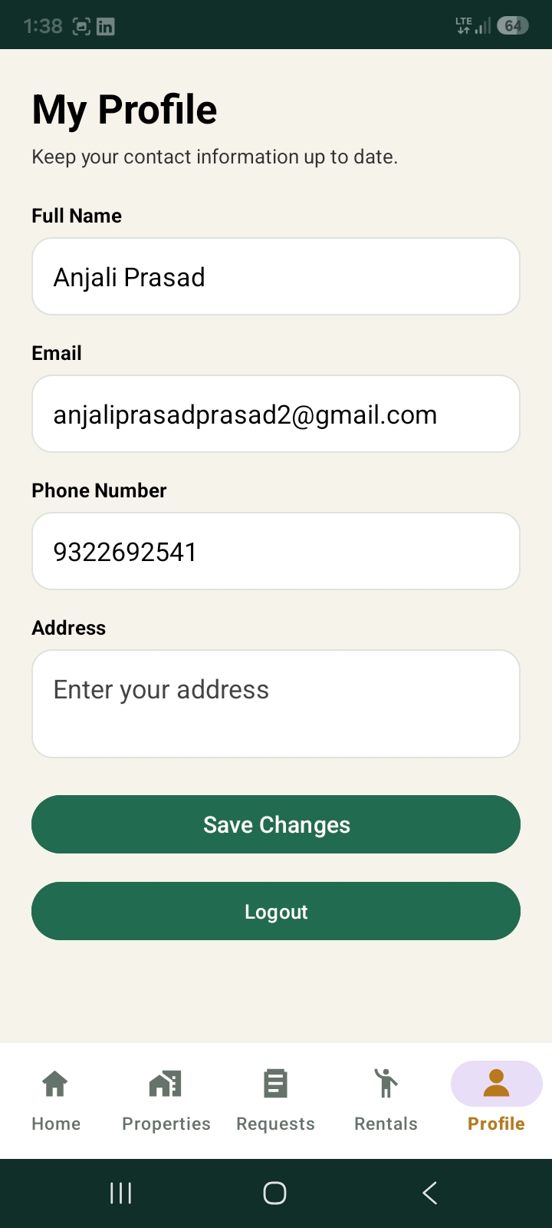
- Room request screen.
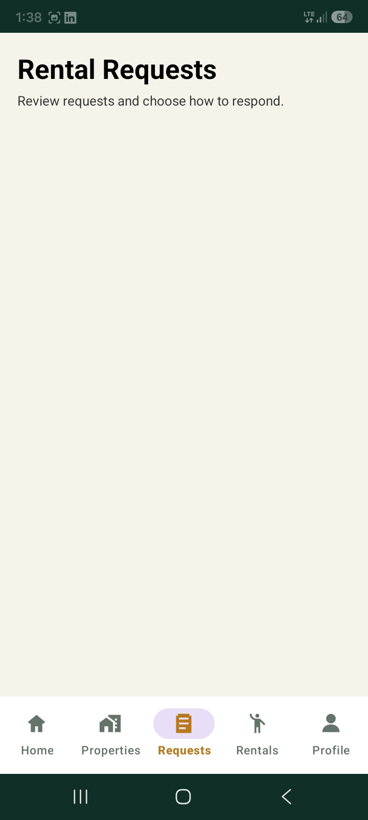
- Owner reviews screen.
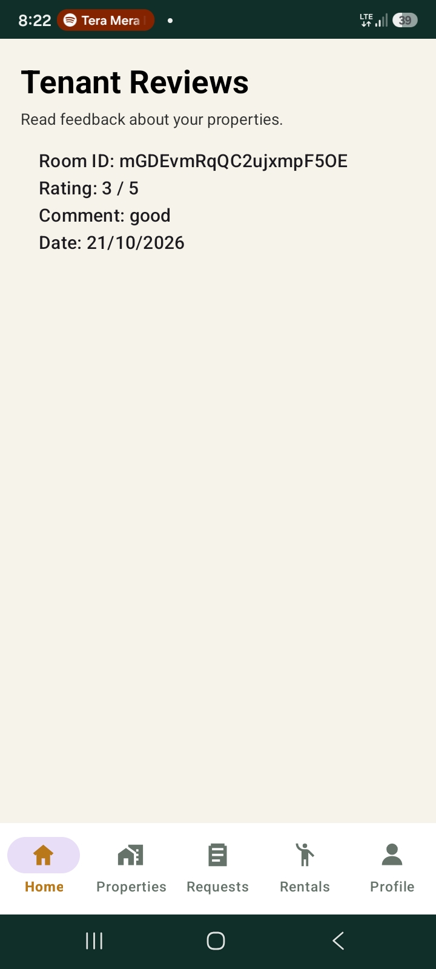
- Owner complaints screen.
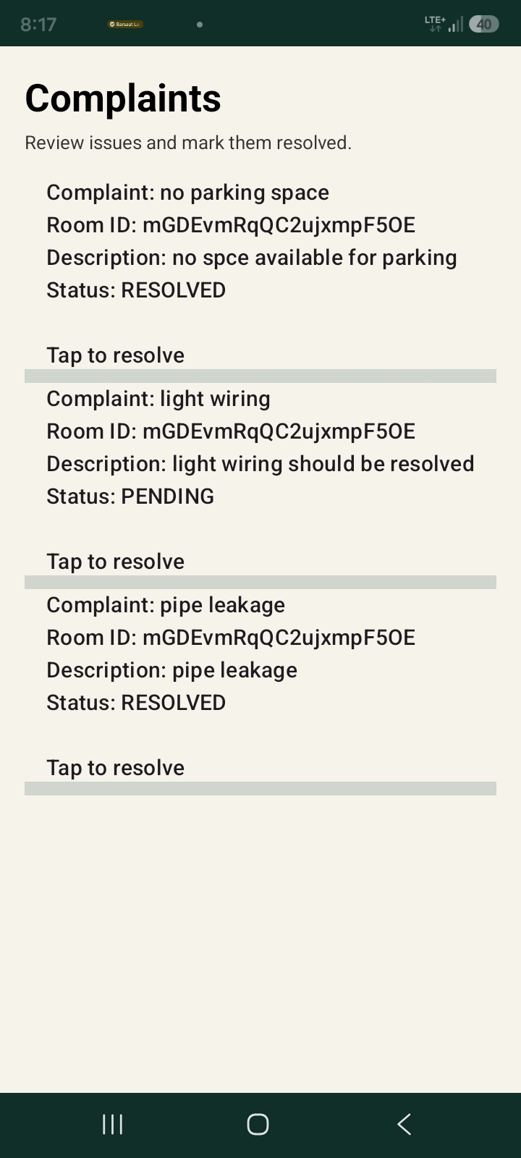
- Tenant reviews screen.
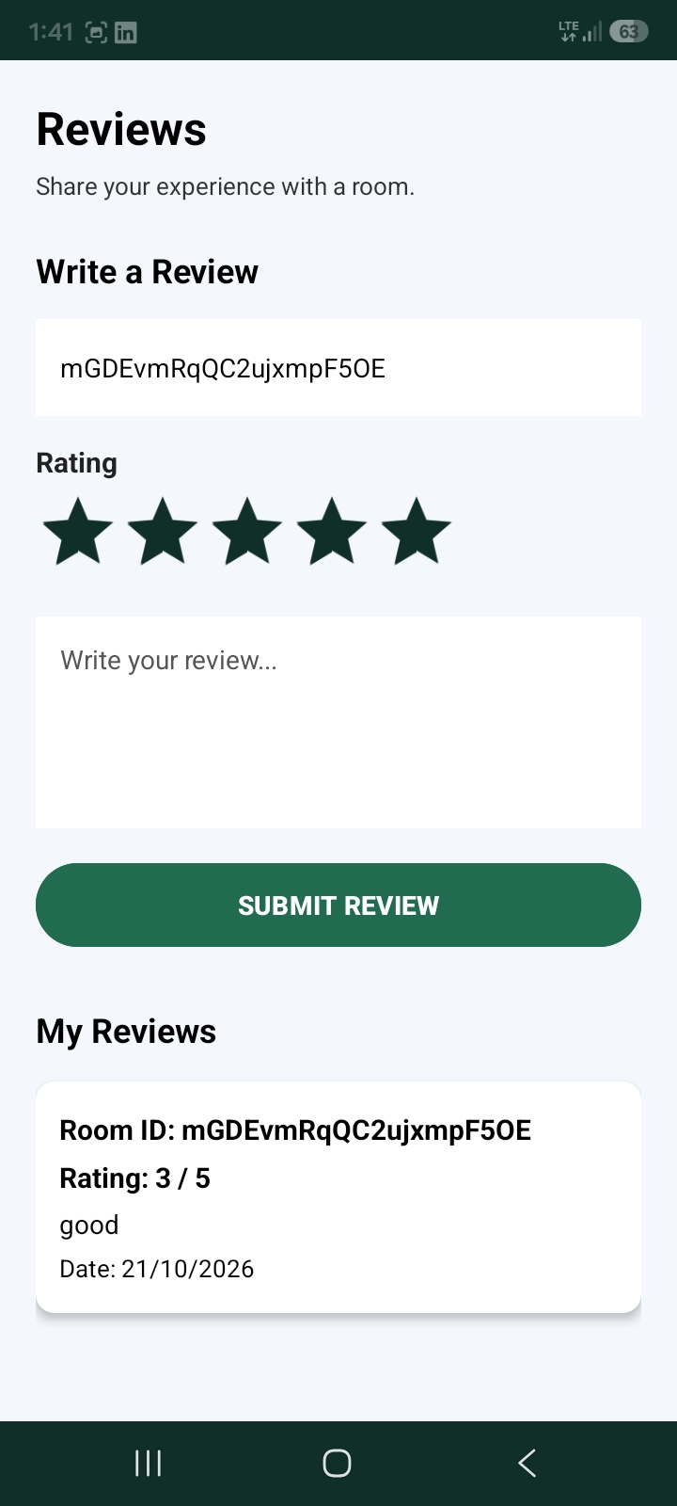
- Tenant complaints screen.
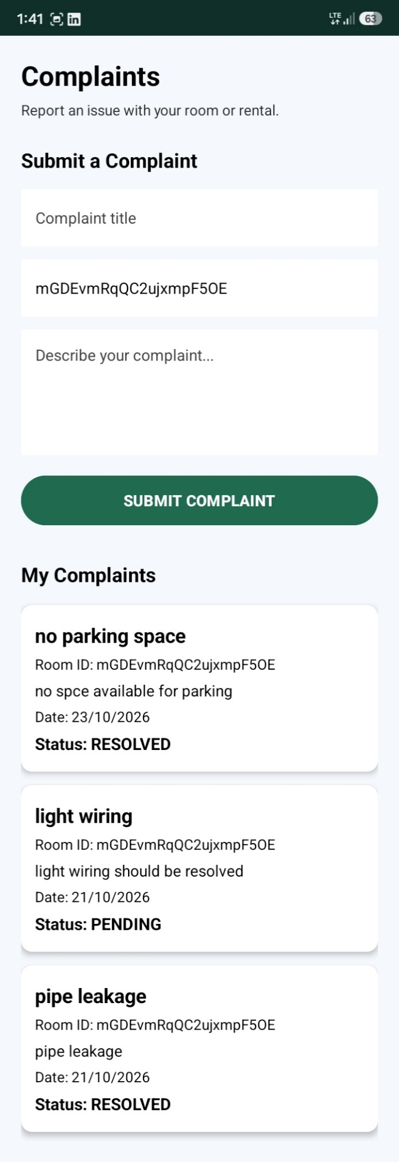
- Monthly payment reminder screen.
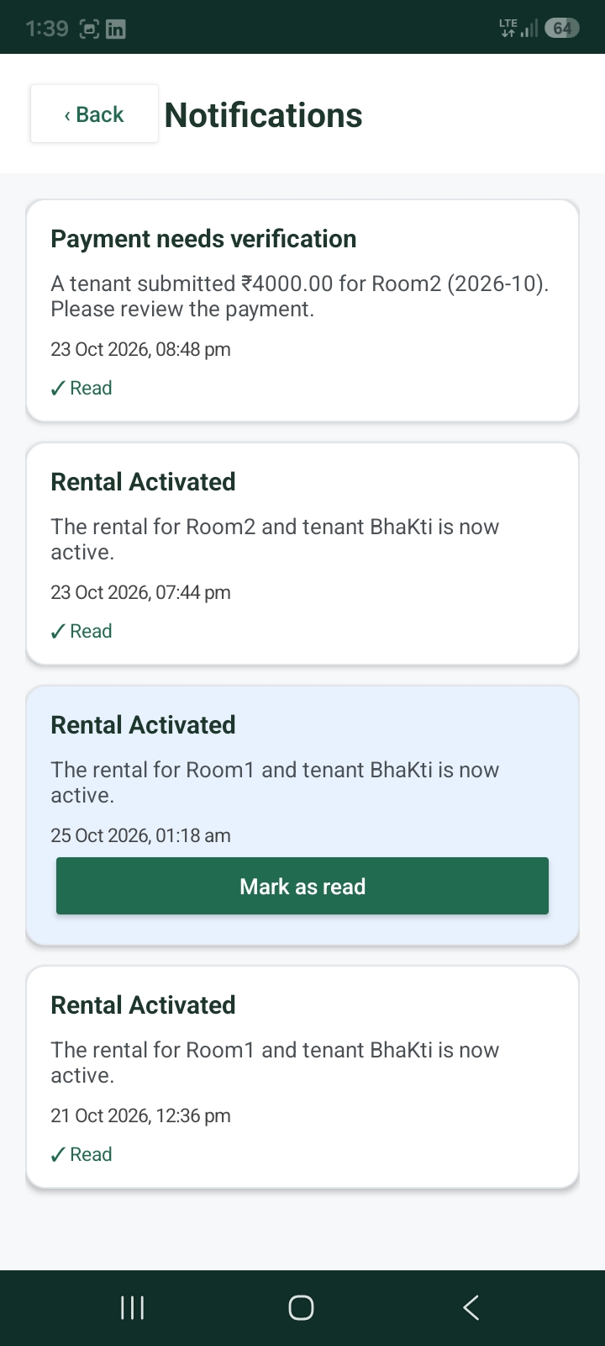
- Chatbot.
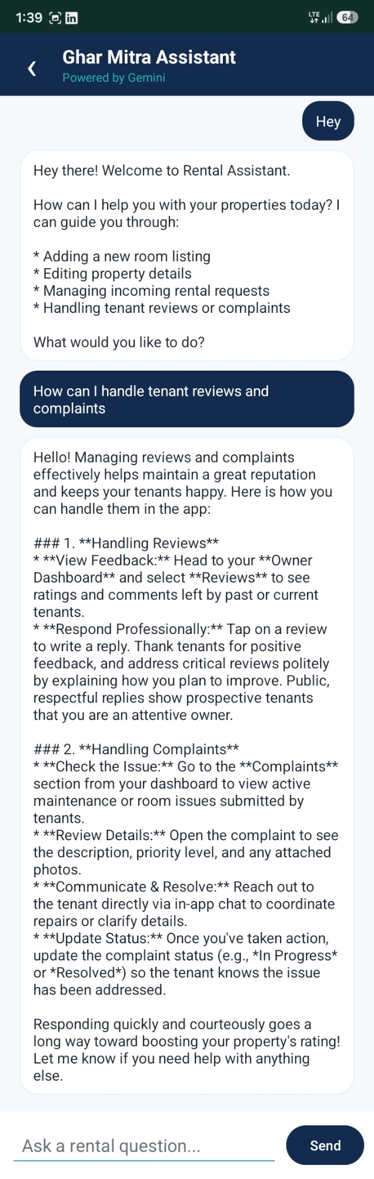
18.4 Discussion
The application brings multiple rental-related functions into a single mobile interface. Its value depends on the accuracy of room information, correctness of role permissions, usability of the interface, and reliability of its backend operations.
Testing should also examine whether the application handles invalid data, network interruptions, and unauthorized access safely.

CHAPTER 19: CHALLENGES AND LIMITATIONS
19.1 Challenges
Potential development challenges include:
- Maintaining separate permissions for tenants and owners.
- Keeping room listings consistent after updates.
- Handling network errors during database operations.
- Validating user input.
- Correctly associating reviews and complaints with rooms.
- Scheduling recurring notifications across Android versions.
- Protecting backend credentials and personal information.
The final report should include the challenges actually encountered by the team and explain how they were addressed.

19.2 Limitations
Potential limitations may include dependence on internet connectivity, reliance on accurate user-provided listing information, limited dispute-resolution functionality, and the absence of payment processing.
Only limitations that apply to the submitted version should be included.

19.3 Security Considerations
Security depends on both the Android application and backend configuration. Appropriate authentication, database rules, role validation, and protection of sensitive configuration values are important for preventing unauthorized access.

19.4 Maintenance
Future maintenance may include updating dependencies, improving validation, correcting reported defects, monitoring backend usage, and adapting the application to newer Android versions.

CHAPTER 20: FUTURE ENHANCEMENTS
The following features could improve the system in future versions:
- Room map integration: Display room locations on a map.
- Advanced filtering: Add more criteria for room comparison.
- Request-status tracking: Allow tenants to view request progress.
- Notifications: Notify owners about new requests and tenants about request updates.
- Complaint tracking: Introduce complaint status and resolution notes.
- In-app messaging: Allow tenants and owners to communicate through a controlled interface.
- Online rent payment: Integrate a secure payment gateway where appropriate.
- Digital rental agreements: Support document generation and signing workflows.
- Improved verification: Add suitable verification mechanisms for users or listings.
- Accessibility improvements: Improve readability, navigation, and support for different device sizes.
- Administrative tools: Add moderation and management capabilities if required.
- Analytics: Provide useful summaries of listings and user activity while respecting privacy.
- Improved reminders: Support reminder customization and clearer notification controls.

CHAPTER 21: CONCLUSION
The Rental Room Management System is designed to provide a convenient mobile platform for organizing rental room activities. By supporting separate tenant and owner accounts, it brings room discovery, listing maintenance, requests, profiles, reviews, complaints, and monthly payment reminders into one application.
The tenant module focuses on finding appropriate rooms and managing rental-related interactions. The owner module focuses on creating and maintaining listings and accessing feedback about those listings.
The project demonstrates the application of Android development, user-interface design, data management, authentication, and role-based functionality to a practical problem.
The quality of the final system depends on the correctness of the implementation, database security, usability, and successful testing. Future enhancements such as request tracking, notifications, online payments, and stronger verification could extend its capabilities.
In conclusion, the project provides a foundation for a more organized rental-room management process and demonstrates how mobile technology can support everyday accommodation-related activities.

REFERENCES
Replace or supplement these references with the exact documentation and libraries used in the project.
- Android Developers, Android development documentation: https://developer.android.com/
- Java Documentation, Oracle: https://docs.oracle.com/en/java/
- Firebase Documentation: https://firebase.google.com/docs
- Firebase Authentication documentation: https://firebase.google.com/docs/auth
- Firebase Realtime Database documentation: https://firebase.google.com/docs/database
- Firebase Cloud Firestore documentation: https://firebase.google.com/docs/firestore
- Android notification documentation: https://developer.android.com/develop/ui/views/notifications
- Android Studio documentation: https://developer.android.com/studio
- Gradle documentation: https://docs.gradle.org/

